Big Data and Cloud Security

By

Nicholas Quinn
22073641

Northumbria University

Master of Science

Cyber Security Technology
Word Count Part A – 3071 Words
Word Count Part B – 1314 Words

03/07/23

Executive Summary

Like most companies of AT’s size and market share, AT is prone to risk. However, the recent management report indicates a lack of effective governance and satisfactory controls in place to mitigate this risk.
This is coupled with data siloing issues, with the use of traditional centralised database systems that are dependent on manual reporting, which is currently leaving the company one step behind of the information curve in a market that is saturated with real-time analytics.
As a result, the company is experiencing unnecessarily high levels of downtime and its current reporting system is undermining travel booking set targets which are currently the only metric of business success due to the lack of data types available.
Therefore, Ace Travel seeks to enhance its data strategy and the purpose of this document is to aide Ace Travel in implementing a successful cloud migration strategy and capitalise on big data.

Table of Contents

Executive Summary 2
List of Figures 5
List of Tables 5
1. Background 6
2. Introduction and scope 6
3. Part A - Big Data Principles 7
3.1 Big Data Paradigm 7
3.2 Big Data in the Cloud 8
3.3 Deployment Models 9
4 Risk Assessment 11
4.1 Vulnerabilities 11
4.2 Threats 12
4.3 Risk analysis and evaluation 13
4.4 Management options 14
5. Comparative analysis of Hadoop and EMR 16
6. High diagram Data Migration diagram 19
6.1 Public Domain and public subnet 19
a. Private subnet 20
b. Private Cloud 20
7. Part B - Ace Travel Cloud Migration Aide Memoir 21
7.1 Creating IAM user accounts. 22
7.2 Creating User Groups 27
7.3 Define Permission Policies 29
7.4 Create S3 Bucket 33
33
7.5 Upload object to S3 38
7.6 Hosting a Static Web Page on S3 40
7.7 Creating EC2 Instances 47
7.8 Connect to EC2 with SSH Windows Power Shell 52
7.9 Connect to EC2 using Putty. 55
8. Security Controls Manual 58
8.1 Enabling Object Lock 59
8.2 Bucket Versioning 61
8.3 Enabling SSE-KMS Server-side encryption. 63
8.4 IAM Access Analyser for S3 66
8.4 Encrypt a running EC2. 68
8.5 Configure EC2 Security Groups 71
9. Data Driven Dashboard 74
9.1 Getting and transforming data 74
9.2 Building a visual report. 78
9.3 Publishing and report sharing. 80
9.4 Creating a cyber security dashboard. 82
10. Best Practices for Social, Ethical, and Legal compliance. 88
10.1 Social consideration 88
10.2 The role of ethics 90
10.3 Legal issues 91
10.4 Recommendations 91
Conclusion 92
Table of References 94

List of Figures

Figure 1: The Three Vs of Big Data (source: Sagiroglu and Sinanc, 2013, p. 42) 7
Figure 2: Characteristic of Cloud Computing (Source: Giyane and Buckley, 2016) 8
Figure 3: Three prospective deployment models (source: Key Strategies for Securing the Hybrid Cloud - Security News, 2018) 11
Figure 4: High level Diagram of public domain and public subnet (source: Quinn, N, 2023) 20
Figure 5: High level diagram of public subnet (Source: Quinn, N, 2023) 21
Figure 6: High level diagram of private cloud (Source: Quinn, N, 2023) 21
Figure 7: Cloud Security Incidents by Company Size 2020 (Source: Statista, 2023) 84

List of Tables

Table 1: Cloud architecture vulnerabilities 11
Table 2: AT threat modelling table 13
Table 3: Risk analysis and evaluation table 14
Table 4: AT shared responsibility modelling table 15
Table 5: Aide Memoir Index table 21

Background

Much ink has been spilt on the term big data in recent years by researchers, practitioners, and industry professionals. The term was first coined by NASA scientists Cox & Ellsworth (1997) to refer to datasets, too large for local storage capacity, and too complex for the processing power of traditional computing.
In the present-day, technological innovation in the form of cloud computing has provided a solution to this problem and made big data available to the masses. Therefore, giving organisation the key to extract value from what is commonly referred to as ‘the new oil’.

Introduction and scope

The aim of this document is to provide the necessary direction and guidance for Ace Travel’s cloud migration strategy, so that it may effectively capitalise on big data, with peace of mind that the security of its information assets and the data privacy of its stakeholders remains in-tact.
Part A will discuss key big data in the cloud concepts to outline the advantages over the company’s current situation. Then it will conduct a risk assessment with the aim of establishing risk treatment options that transfer suitable levels of risk by adopting an optimal service model of shared responsibility. This section will close with a discussion on suitable big data frameworks and the recommended tools, and auditing methodologies AT should utilise, with a high-level diagram to show how this should be implemented.
Part B will provide users of this document with an aide memoir to be used as a point of reference when setting up the cloud environment, along with a supplemental safety manual and an example of visuals tools which the company can use for its business intelligence. This part will close with a brief discussion on the implications of data privacy that runs along social, ethical, and legal dimensions and how to implement good practices at management level to ensure Ace Travel maintains compliance across all these dimensions.

Part A - Big Data Principles

3.1 Big Data Paradigm

There is no formally accepted definition for Big Data. De Mauro et al (2015, pp. 101-103) surveys subsequent definitions contemporary to this paradigm shift, concluding that Big Data represents Information assets characterized by such a High Volume, Velocity and Variety to require specific Technology and Analytical Methods for their transformation into Value.
Sagiroglu and Sinanc, (2013, pp. 42-43) analyses former components of this definition often interpreted as the characteristics of Big Data – the 3 V’s (Figure 1). This analysis provides the basis for discussion on how Big Data principles can be applied in the context of AT’s cloud migration to achieve the fourth V (value extraction) in reference to the previously mentioned definition.
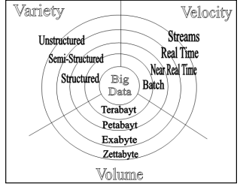
Variety refers to sources and data types. According to Mayer-Schönberger and Cukier (2017, p. 47), structured data is only capable of accessing 5 percent of the digital data available. This is relevant to AT as Structured query language (SQL) increasingly shifts towards Not Only SQL (NoSQL) to make vast data sets of varying size and quality available (Mayer-Schönberger and Cukier 2017, pp.44-48), because tourism has generated vast amounts of data from various sources (Li et al., 2018, p. 302), such as:
Figure 1: The Three Vs of Big Data (source: Sagiroglu and Sinanc, 2013, p. 42)

- Users with the growth of social media platforms and the spread of User Generated Content (UGS)
- Devices generating considerable spatial temporal data.
- and Operations which produce corresponding transactional data through web searches, web page visiting online booking etc
Therefore, exploitation of semi-structured and unstructured data types, may provide AT the ability to extract value from the remaining 95 percent of datasets made available by these sources and gain valuable insights into the travel packages, airline tickets and hotel places offered to online consumers.
Volume refers to quantity and size of datasets available for storage and processing. The attributes of variety drive increasing volume and presents challenges to traditional IT infrastructure, calling for scalable storage solutions and efficient processing methods to query relevant data to extract value (Syed et al., 2013, p. 2447). This somewhat overlaps with data Velocity which refers to both the speed and intensity of data flow into businesses, and the ability of the data processes to extract value (Sagiroglu and Sinanc, 2013, p. 43).
Cloud is the commonly accepted optimal solution for storing, processing, and analysing Big Data (Berisha et al., 2022, p. 10).This confluence has coined the term ‘Big Data in the Cloud’ – a concept that researchers, such as Hashem et al (2015, p. 113) agree is transforming industries across various sectors by providing real-time insights to inform business decisions.

Big Data in the Cloud
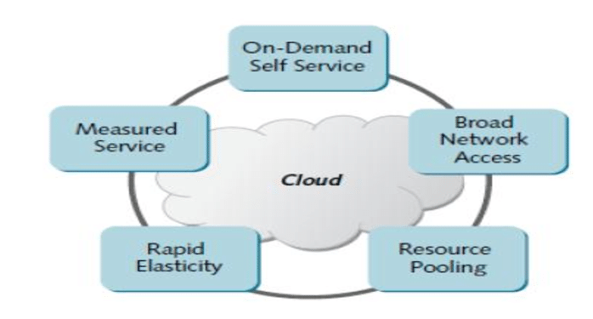
The National Institute of Standards and Technology (NIST) definition, of cloud computing provides a taxonomy for cloud computing, composed of five essential characteristics (Figure 2), (Mell and Grance, 2011, p. 2). These cloud computing concepts provide clear advantages over the current situation.
Figure 2: Characteristic of Cloud Computing (Source: Giyane and Buckley, 2016)

Rapidly deployed resources would give AT much more business agility. This is made possible because Cloud Service Providers (CSP) can pool resources and re-assign them virtually to consumers at specified locations or regions, therefore giving consumers on demand self-service capacity, where resources can be provisioned without human interaction (Mell and Grance, 2009, p. 2.).
This makes services highly available, meaning that resources can be allocated through online web portals, command line interfaces, or by using Application Programming Interfaces (API) to send requests to cloud abstractions (Bigelow, 2020), enabling almost complete automation and streamlining AT’s business processes.
Having pooled resources on demand, gives AT the ability to scale up and out, and then reduce these resources at low hours - a characteristic of cloud computing known as rapid elasticity (Ruperelia, 2016, p. 18). This would enable AT to meet the demands of increasing database queries at peak hours to reduce downtime.
In fact, the company would be able to specify a Service Level Agreement with the CSP to determine the measurable aspects of the service (Ruperelia, 2016, pp. 10-11), including the up time and the security measures, which could be factored into, or completely abstracted from AT’s Disaster Recovery Plan (DRP)
These concepts enhance the availability of AT’s data assets by offering ubiquitous network access whereby data can be accessed anywhere with sufficient bandwidth and connectivity. This aspect of Cloud Computing should mitigate interoperability issues caused by AT’s centralised data siloing, because datasets would become accessible to regional managers from various platforms without the need for manual report sharing.

Deployment Models

A Public cloud, where clients access services from the internet commonly used for this type of solution. This deployment model typically offers the most agility and availability because it is deployed and managed by a dedicated Cloud Service Provider (CSP) like Amazon Web Services (AWS) or Microsoft Azure, who have industry standard expertise and large scales of resources pooled at various regional location.
This would also be a cost-effective solution for AT because it would be typically delivered as a metered service using operational expenditure pricing model, requiring no up-front capital costs (Ruperelia, 2016, p. 30).
However, this increase in accessibility carries the higher risk of security compromise, forcing companies to consider private clouds (Ruperelia, 2016, p. 16), which are deployed and managed on premises and typically accessed over private networks entry points such as Virtual Private Network (VPN).
This would give AT much more control and allow them to customise the cloud to meet any specific contractual, regulatory, or legal requirements, for example a stakeholder may specify that their data be restricted to private systems. This would come at the cost of capital expenditure (CAP-EX) for AT to build on its existing infrastructure and outsource IT specialists to deploy and maintain the network as well longer deployment timeframes making this a less agile solution.
Figure 3: Three prospective deployment models (source: Key Strategies for Securing the Hybrid Cloud - Security News, 2018)

Therefore, the company should opt for a hybrid solution which combines a private cloud scaled out from its existing infrastructure to perform processes with specific sensitivity criteria and a public cloud for large scale data operations that require a high degree of elasticity.

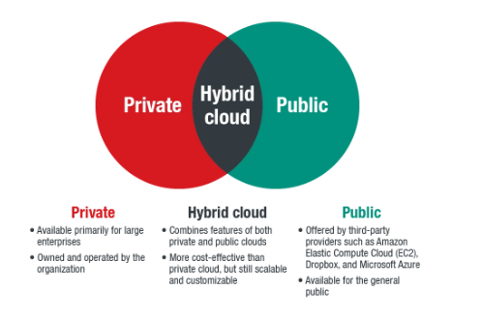

Risk Assessment

This risk assessment (RA) was conducted using the ISO/IEC 27001 framework to address security concerns for AT’s cloud migration strategy and determine a risk treatment plan with suitable management options.

4.1 Vulnerabilities

There are numerous vulnerabilities inherent in the Cloud Architecture (Table 1). These provide threat actors such as cyber criminals, state threats, cyber terrorists/spies, or insiders with malicious motives with opportunities to exploit the attack surfaces between users, services and CSP’s during cloud interactions (Javed Butt et al., 2021).

Table 1: Cloud architecture vulnerabilities
Architecture/Assets | Vulnerability
Application/middleware/API’s  Client facing Business function software and APIs used to interact with middleware components. | Vulnerable to traditional OSI level 7 attacks OWASP (2021).  API’s expose sensitive information and programme logic (OWASP, 2023).
Runtime Environment  E.g., web browsers used as a runtime for java-script libraries or containers used for application development. | Web browsers vulnerable to OSI level 7 attacks when used to run external scripts (Javed Butt et al., 2021), containers can be used as a backdoor or host specific software vulnerabilities.
OS  Cloud technology means that AT will have agile access to potentially unfamiliar operating systems | Malware, unless hardened by security measures
Virtual Machines  Foundational provision across all service models. | CSP to Service user attack service, Denial of Service (DDoS) attacks (Javed Butt et al., 2021).
Servers/ Hypervisors  Software /operating system used to create virtual resources | Bugs in mechanisms used to separate different tenants of the shared infrastructure (Karadsheh, 2012, p. 319).
Virtual Networks  Data is transmitted through the IP networks in the cloud | Traditional Domain Name Severs (DNS) Dynamic Host Configuration Protocol (DHCP), and Internet Protocol (IP) vulnerabilities (Yang et al., 2020, p. 131725
Storage  Storage is hosted by multitenant containers for various storage types. | Mismanagement of the multitenant environment (Yang et al., 2020, p. 131725)

4.2 Threats

This equates to risks to the Confidentiality, Integrity, and Availability (CIA) of AT’s datasets and compliance issues that will likely incur substantial business losses, penalty fines and reputational damage.
This RA uses the STRIDE threat modelling tools to display likely malicious threat attack methods (Table 2), however non-malign threats, which were identified in the management report were brought forward to the risk analysis in section 4.3.

Table 2: AT threat modelling table
ASSET | S | T | R | I | D | E | Unwanted Occurrence (CIA)
Application  Middleware (API) | x | x | x | x | x | x | Traditional client to server OSI L7 model attacks  (CIA)
Runtime |  | x |  | x | x | x | C – Container escape  I – script modification
OS | x |  |  |  | x | x | C – Spoofing/Social engineering gains entity access to OS  I – System cannot identify illegitimate user privileges or prevent user from making system modification.  A – User makes changes to system to block access to critical data
VM |  |  |  |  | x | x | C – entity gains escalation of privileges to AT cloud resources and used in malicious attack (i.e., DDoS)  A – Threat actors overwhelm AT system resources with external OSI level 7 attack, triggering auto- scale
Servers/ Hypervisor |  |  |  | x | x | x | C – Unauthorised entity exploits separation mechanisms in hypervisor
Virtual Network | x | x |  |  | x | x | Traditional risk to data in transit such as  C - Data theft,  I – Tampering.  A – Denial of service
Managed Storage |  | x |  | x |  | x | C - Unauthorized access and leakage of data at rest.

4.3 Risk analysis and evaluation

The Risk analysis is shown in Table 3. Management investigation reported a high level of downtime due to multiple attacks at various OSI levels, server overloads and backup delays and. Therefore, this qualitative analysis regards the likeliness of mentioned unwanted occurrences as high by default.
Parameters for the level of impact, were qualified using the CIA model, rating each property at a value of 1-lowest to 3-highest. The aggregate was taken an assigned a value between the following impact ranges:
- 0-3 = low
- 4-8 = medium
- 9-12 = high
This was then evaluated combined with the likelihood values using the formular: Risk = impact + likelihood to give the risk rating

Table 3: Risk analysis and evaluation table
Unwanted Occurrence | Confidentiality | Integrity | Availability | Likeliness | Rating
OSI L7 attacks | 3 | 3 | 3 | 3 | High
Container escape | 3 | 1 | 2 | 3 | High
script modification | 1 | 3 | 1 | 3 | Medium
Spoofing/Social engineering | 3 | 1 | 1 | 3 | Medium
system modification | 1 | 3 | 1 | 3 | Medium
Denial of service to critical data | 1 | 1 | 3 | 3 | High
Botnet Acquisition | 1 | 3 | 1 | 3 | Medium
External DDoS | 1 | 3 | 3 | 3 | High
Hypervisor Defeat | 3 | 1 | 1 | 3 | Medium
Data theft | 3 | 3 | 1 | 3 | High
Data Tampering | 3 | 3 | 1 | 3 | High
Data leakage | 3 | 3 | 1 | 3 | High
Sever Overloads | 1 | 1 | 3 | 3 | Medium
Backup Delays | 1 | 1 | 3 | 3 | Medium

4.4 Management options

The security breach of a major UK travel operator of AT’s scale with a turnover of over £3 million per year, will result in severe operational and reputational damage. Moreover, AT will likely incur substantial penalty fines of up to 4% of its annual revenue because of DPA (2018) infringement as shown in the British Airways incident (Guida, 2021).
Therefore, it AT should adopt a low-risk appetite and determine appropriate measures to modify the identified risks. However, the management investigation has indicated a low level of competency at IT infrastructure configuration and Information Assurance, therefore it is recommended that the company adopts an approach whereby risk is transferred to a third party CSP and establishes an SLA with clear and explicit boundaries of shared responsibility.
The NIST taxonomy outlines three fundamental services models within the cloud computing composition offering various levels of shared responsibility. They are infrastructure as a service, (IAAS), platform as a service (PAAS), and software as a service (SAAS) (Mell & Grance, 2011).
Table 4 shows the level of responsibility applicable to AT in with the adoption of a particular service model in blue in contract to the level of abstraction in green. IAAS is the provision of processing, storage, networks, and other fundamental computing resources where the consumer can deploy and run arbitrary software, which can include operating systems and applications (Mell & Grance, 2011, p.2).
This places the lion’s share of the responsibility over the configuration and management of the architecture. Therefore, indicating that solely from a security standpoint, IAAS would be the least preferable option.
In contrast, SAAS would be the most preferable option, as the capability provided to the consumer is to use the provider’s applications running on a cloud infrastructure without having to manage any of the underlying infrastructure (Mell & Grance, 2011, p.2)

Table 4: AT shared responsibility modelling table
On Premises | IAAS | PAAS | SAAS
Data
Application
Runtime
Middleware
OS
Virtualisation
Servers
Networking
Storage

However, Ruparelia’s (2016) swat analysis indicates that AT will be restricted to data formats used by the vendor. AT must consider the methods and tools for storing and processing high volumes of data, from multiple sources and format types and at fluctuating velocities, to extract value. Therefore, less optimal from the standpoint of flexibility or enterprise.
Thus, AT should opt for a PAAS model, whereby, they would not manage or control the underlying cloud infrastructure including network, servers, operating systems, or storage, but would have control over the deployed applications (Mell & Grance, 2011, p. 2).
This model offers them the agility to develop application using methods and tools to enhance their big data strategy with a CSP that can integrate tools for compliance, assurance, and auditing methodologies, as discussed in section 5.
.

Comparative analysis of Hadoop and EMR

Hadoop is an open-source framework for storing large datasets to enable the implementation of Map Reduce. This is built on Java-based, Hadoop distributed file system (HDFS) that allows persistent and reliable storage and fast access to large amounts of data across large clusters of computers by dividing files into large blocks and saving them redundantly (Azeroual & Fabre, 2021, p. 5).
The HDFS architecture primarily consists of nodes (Servers) with differing functions: such as name nodes which store metadata and handle requests and data nodes which store the application data locally (Perwej, 2019, p. 1). The Map Reduce Programming algorithm is run on the local servers to process and extract value from the data. This data locality and use of data redundancy means that HDFS is an inherently fault tolerant system with high throughput and low latency.
Yarn, which is the resource manager for the Hadoop framework, enables the HDFS to be compatible with processing frameworks outside of the Map reduce algorithms, such as Apache Spark which can process real time data from event streams (Chebbi et al., 2018, p. 4).
However, Sparks security is currently in its infancy, offering only authentication support through shared password authentication (Chebbi et al., 2018, p. 4). Therefore, running Spark on Yarn is a viable course of action from a security perspective as this would enable the use of Yarns superior security features.
These include Kerberos and network access control lists, which Perwej (2019, p. 4) believes makes Hadoop framework resilient to unauthorised access when installed with clearly defined user roles, multifactor authentication (MFA) and encryption for confidential data.
However, Rajeh, (2022, pp. 28-29) disagrees, arguing that the absence of fine-grained access control between name nodes and data nodes, and built in logging and auditing features that support user access monitoring and compliance with security requirements, create deficiencies in this framework’s security layers.
In contrast Amazon Elastic Map Reduce (EMR) which is an implementation of the Hadoop framework hosted by AWS, is a managed service. This integrates with IAM policies which allows root users to create user accounts which can be granted role-based permissions (Mishra et al., 2022, p. 617), thus, enforcing fine grained access control in compliance with security best practises such as least privileges.
EMR is also compatible with other on-demand services, such as Cloud trail. This logs, monitors and records activities in the management console and tracks API usage (AWS, 2023). AWS audit manager is used to generate reports, with links to supporting evidence which can be customised to meet the requirements of prominent data privacy and security frameworks (AWS, 2023).
These services reflect auditing practice outlined by the NCSC (2023) which stipulates that organisations should adopt CSP’s that can provide timely audit data in a usable format to react dynamically to cyber incidents and includes features such as logging records are stored in Simple Storage Service (S3 bucket) which maintains compliance with Section 62 (4) of the DPA (2018).
This indicates that managed services, such as Amazon EMR are developed to meet independent compliance requirements which are aligned to zero trust best practices. This is advantageous over the adoption of the Hadoop framework alone, which according to Rajeh, (2022, p. 28) , is built upon the notion that a certain level of trust exists within the system.
Other advantages are the abstracted responsibilities over security maintenance and configuration. If AT were to adopt the Hadoop framework, they would be responsible for patch management, security updates and configuration of encryption options which are compatible with HDFS. All other security aspects beyond this would also need to be considered, provisioned, and managed by AT.
In contrast, with EMR, AWS would manage the patching and security updates of underlying infrastructure on lease to AT. AWS also provision server-side and client – side encryption for data at rest and in transit with AWS Key Management Service (KWS) (Choudhary, 2021, p. 94).
However, AWS extends far beyond these aspects of security, offering services to mitigate risks outlined in section 4. Users can subscribe to Shield which is a DDoS specific service or manually mitigate incoming DDoS and other OSI level 7 attacks such cross-site scripting, SQL injection, or others listed in OWASP (2021) by rapid deployment of AWS Web application firewalls (WAF) which can be configured to block unwanted network traffic.
To summarise key differences between Hadoop and AWS, both frameworks can deliver the capacity for AT to exploit big data. However, Hadoop is a component of the EMR managed service.
This service extends much wider than Hadoop alone, because it offers all the advantages of Hadoop, coupled with those of cloud computing outlined in section 3 and from a security standpoint it could aide AT in identifying, mitigating, and responding to security incidents dynamically, as well as meeting regulatory requirements.

High diagram Data Migration diagram

AT will deploy a hybrid cloud comprised of highly scalable big data solutions with broad network access to mitigate interoperability issues, and a private cloud to handle sensitive PII such as employee data and stakeholder information which has been explicitly requested to be restricted to a private cloud.
All services will be supported by IAM access control policies, encryption and SSH key pairs. The system is protected by AWS shield advanced, Kerberos and AWS WAF and supported by CloudTrail for auditing and Audit manager to maintain compliance.

6.1 Public Domain and public subnet
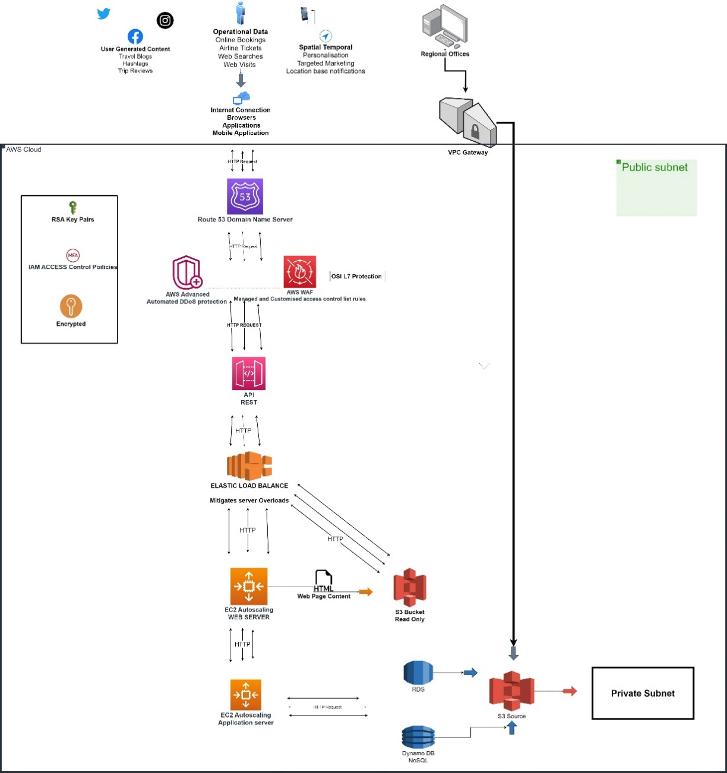
Figure 4: High level Diagram of public domain and public subnet (source: Quinn, N, 2023)

Private subnet
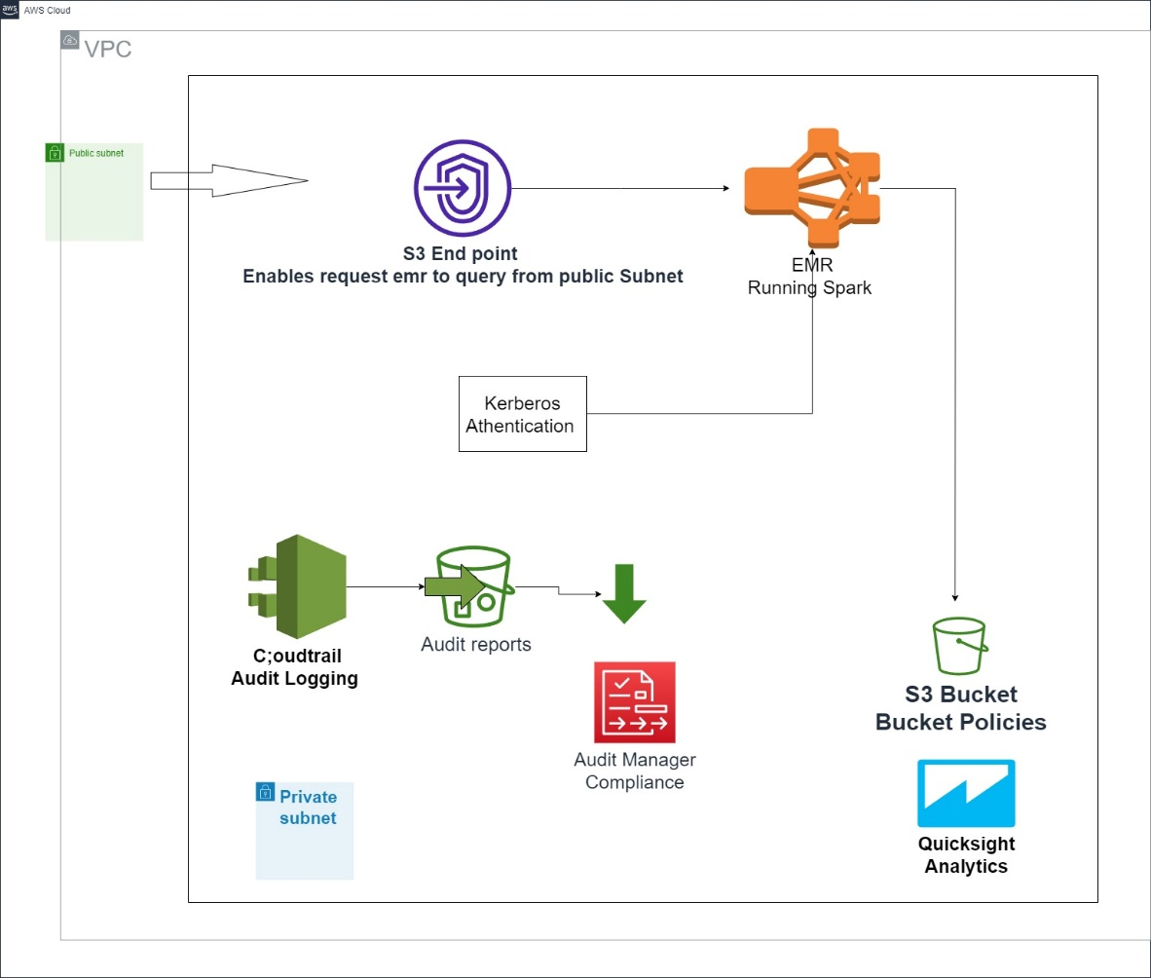
Figure 5: High level diagram of public subnet (Source: Quinn, N, 2023)

Private Cloud
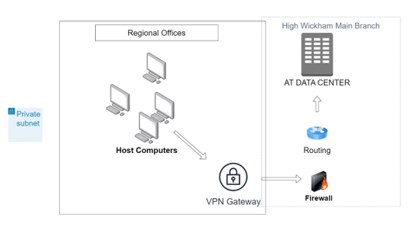

Figure 6: High level diagram of private cloud (Source: Quinn, N, 2023)

Part B - Ace Travel Cloud Migration Aide Memoir

Please revert to the table below to index a specific procedure. Use numbering system and follow the steps laid out to implement each configuration.

Table 5: Aide Memoir Index table
Procedure | Page
Creating IAM user accounts | 22
Creating User groups | 27
Defining Permissions | 29
Create S3 Buckets | 33
Upload Object to S3 Bucket | 38
Host Static Web Page with S3 | 40
Create EC2 Instance | 47
Connect to EC2 with PowerShell | 52
Connect to EC2 with PuTTy | 55

7.1 Creating IAM user accounts.
1
Select the search bar and navigate to the Identity and Access Management (IAM) service from the search bar.
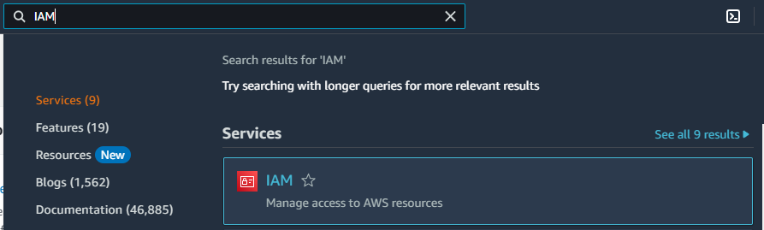
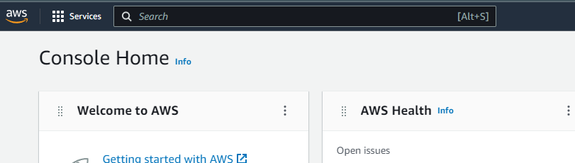

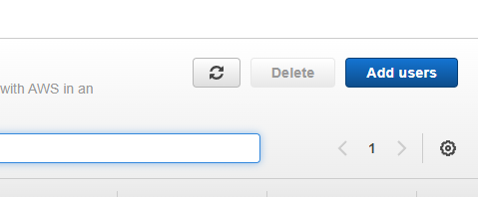
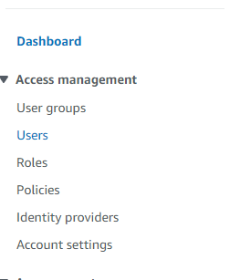
2
Select Users/ add users on the landing page.

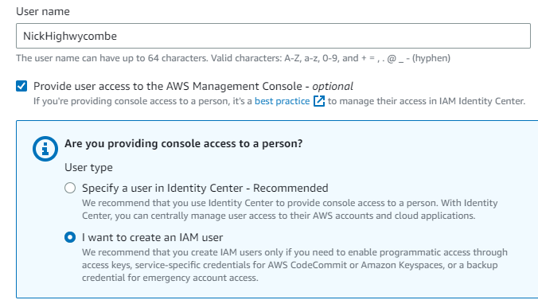
2
Create username and select IAM user account for user groups that will be assigned higher levels of system access to such as administration groups, bookings etc.

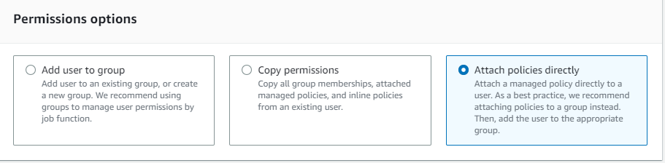
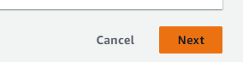
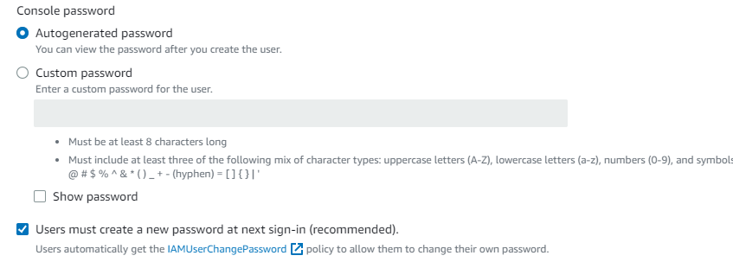
3
Choose between autogenerated or custom password. Select show password to generate email invitation. User will be prompted to change the password. Select next.
4
At this stage users outside of a group may be assigned permissions. The following stages will demonstrate how to attach full access permissions to an administrator for the S3 bucket.
Note
Permissions contained in the policy as well as other properties can be viewed by selecting the desired policy.
Click next when policies are selected.
5
Search S3 (or desired service) in the search bar under permissions policies
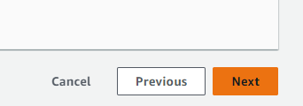
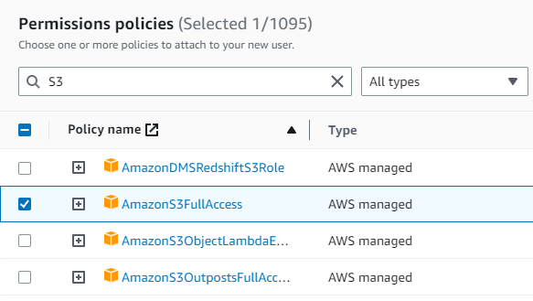

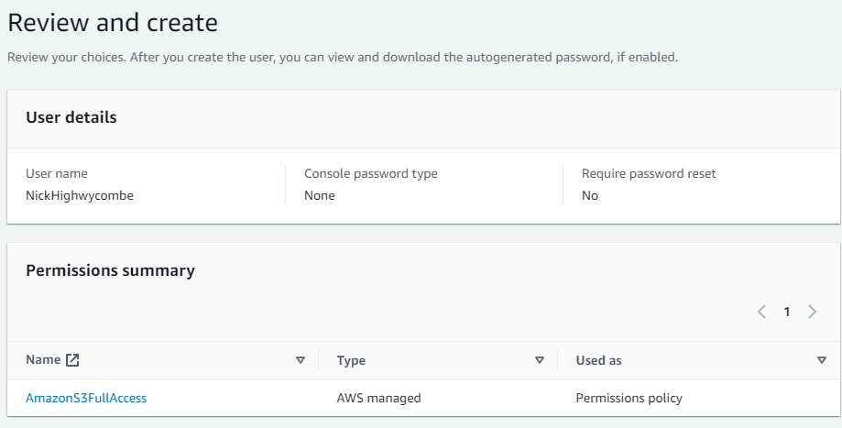

6
Review the summary of the user details with the corresponding permissions and create.

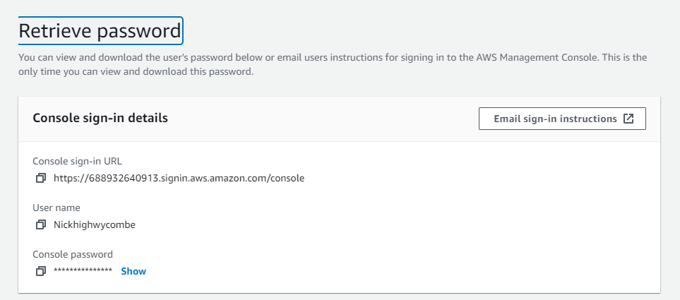

7
Select option for email generated invitation. CSV file is available to download and attach to the user. User will be prompted to change password at initial log in.
User successfully created.

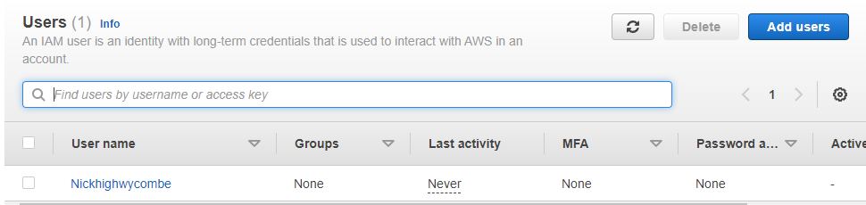

7.2 Creating User Groups

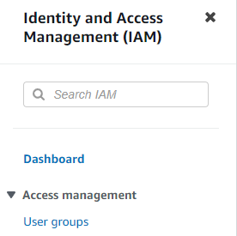
1
Select user groups in the IAM console. Once on the landing page select create group.

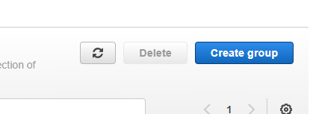

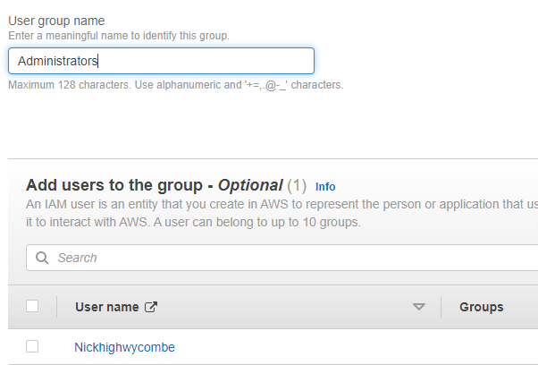
2
On the following page, select a group name and add any composite group members if required.
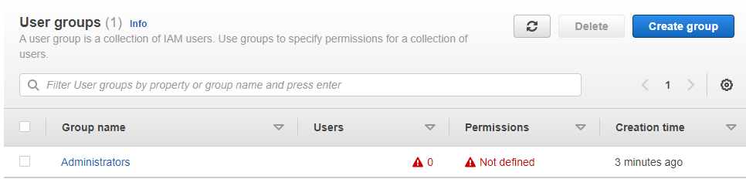

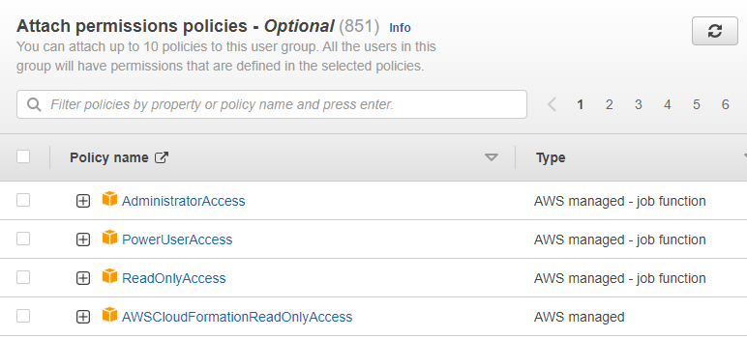
4
User group successfully created.
Note
Group currently has no defined permissions – following subsection will create a custom policy for the group.
3
Attach required permissions policies.
Note
Users who are attached to the group will assume attached group permissions. Individual users with pre-existing policies will retain permissions regardless of group policies.
Create group.

7.3 Define Permission Policies
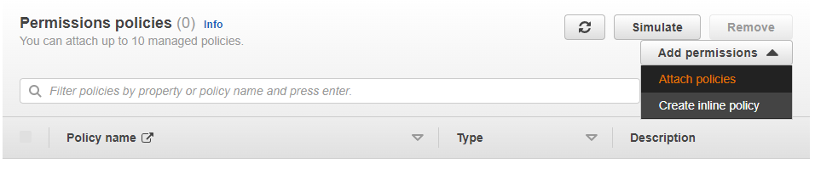
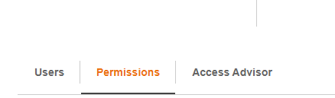
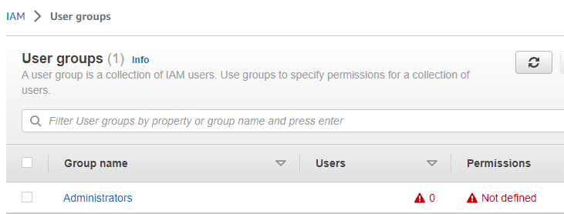
2
Select the option to create inline policy.
Note
This example will create a policy to the Administrator user group to create S3 buckets.

1
To define a permissions policy, begin by selecting a group. On the following page select permissions
Note
This process can also be applied to individual users.

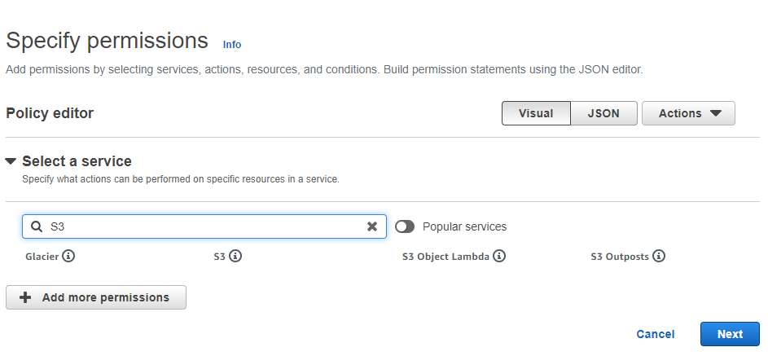
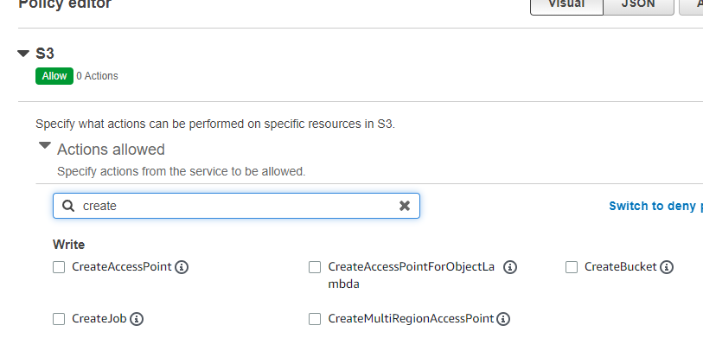
4
Searches create and check the CreateBucket option.
Note
Function also available in JSON format
3
Select S3 in search bar and select S3 services.
5
Specify resources the policy applies to.
Note
Users can opt for specific Amazon Resource name to apply granular access control to specific resources.
However, this demonstration will apply to all as resources are yet to be created.
Select next.

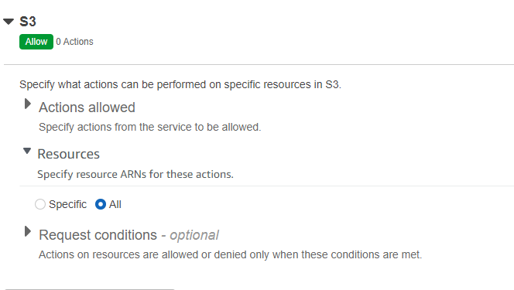



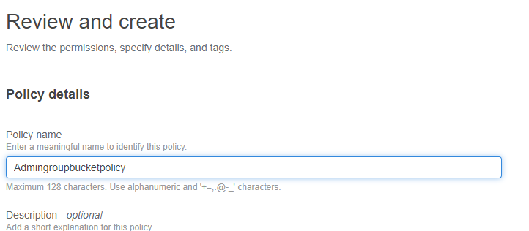
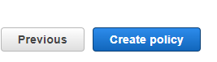
6
Name group and create policy.

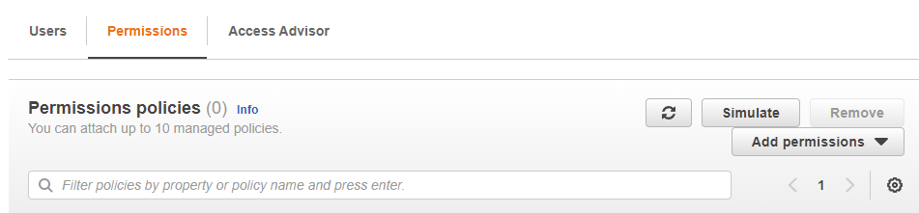
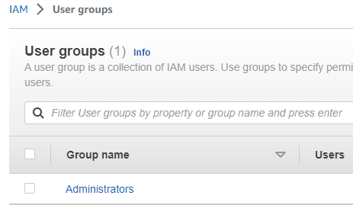
7
Return to the user group landing page and select the required group to attach the policy to.
On the flowing page select the permissions tab and then add permissions

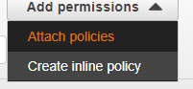
8
Select the option to attach policies.
Check the created policy and add permissions and the policy will be added to the user group.

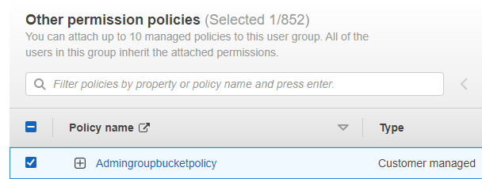



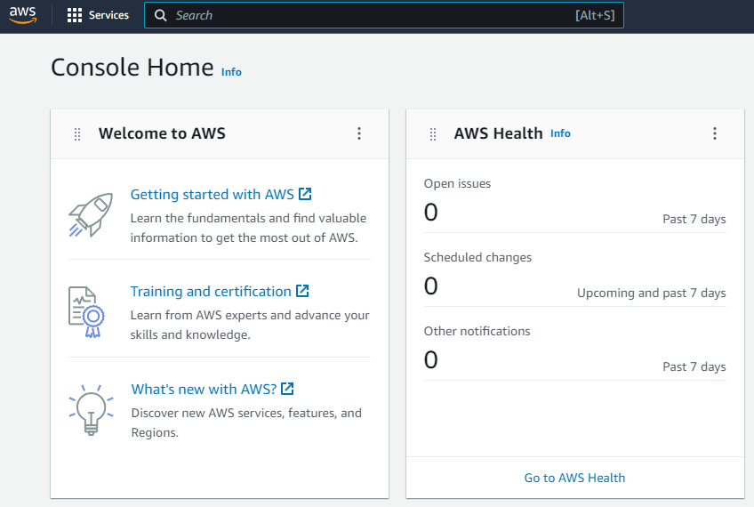
7.4 Create S3 Bucket

1
Sign into the management console and select services at the top left of the console.

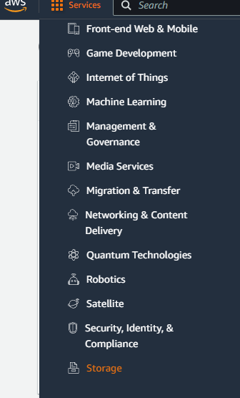
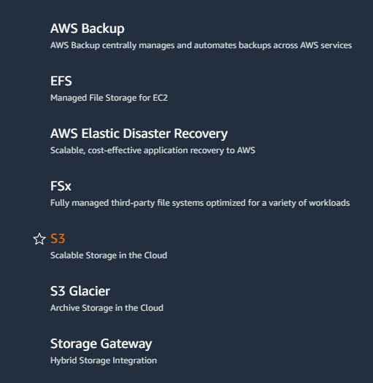

3
Select S3
2
Select Storage

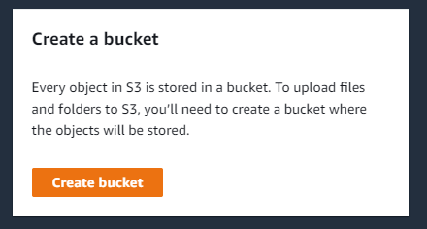
4
Select create bucket.
6
Enter a bucket name.
Name cannot be changed once bucket is created.

5
Select see rules for bucket naming to view parameters for naming the bucket.
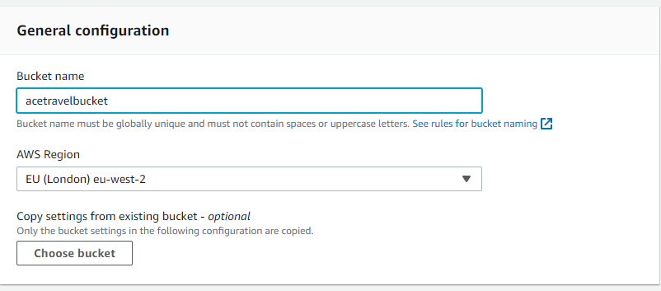
l

7
All AT branches operate in eu-west-2
Region

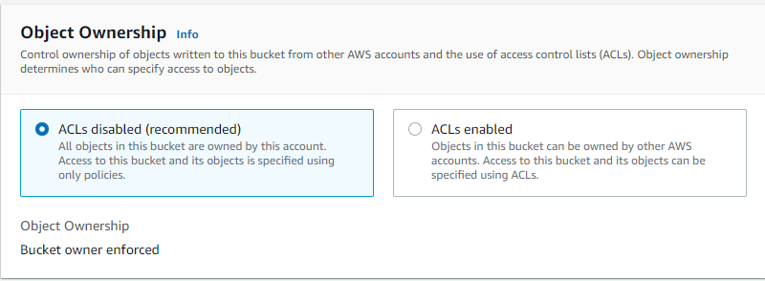

8
Ace travel will define permissions and access controls using Identity and Access Management (IAM) policies. Therefore, ACL’s will not be relied on and will be disabled with the option to block all public access selected.

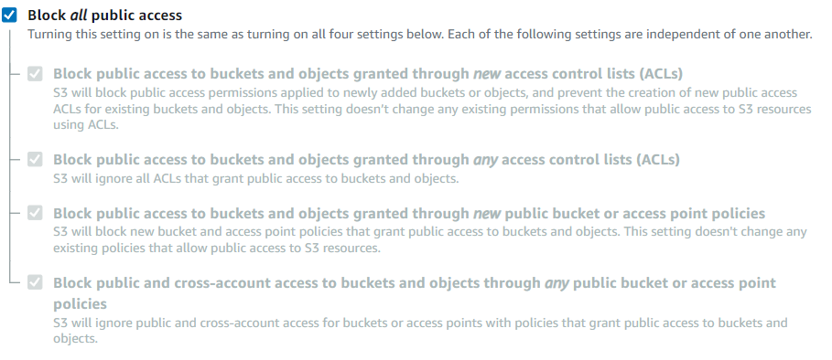

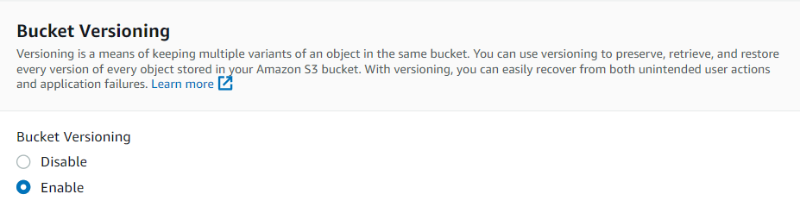
9
Bucket Versioning will be enabled for recovery, restoration, and compliance purposes.

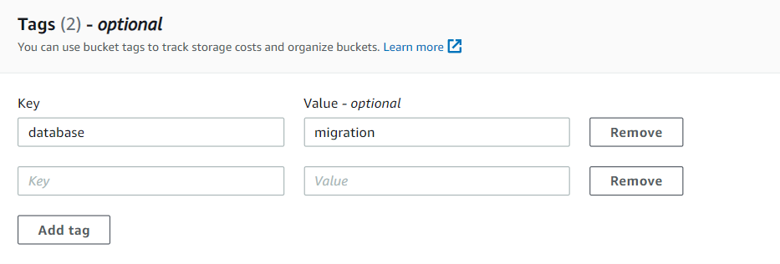

10
There will be S3 used for database migration, storing audit reports, and storing data for analytics in the workflow, therefore Ace travel should use tags to track costs and other properties of each resource.

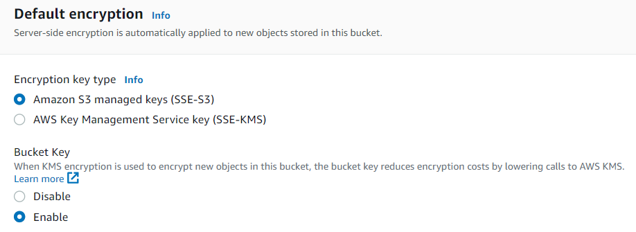
11
Select S3 managed keys (SSE-S3)

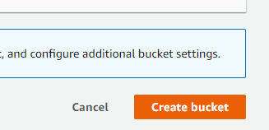

12
Create Bucket

7.5 Upload object to S3

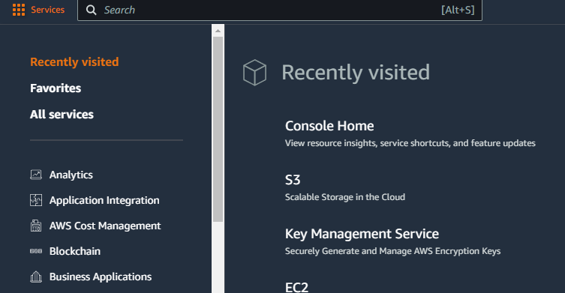

1
Navigate to the S3 console.

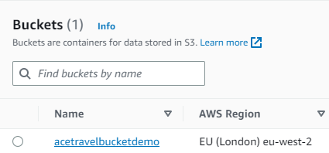
2
Select the required bucket.

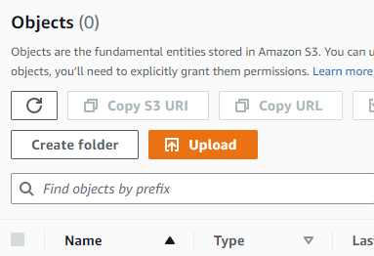
3
Choose upload.

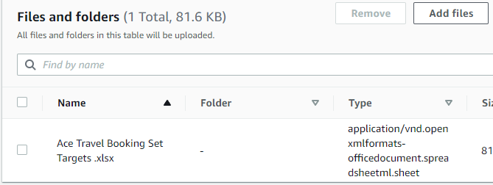

4
Select add files. Chosen file will appear once an object has been chosen and added.

7.6 Hosting a Static Web Page on S3

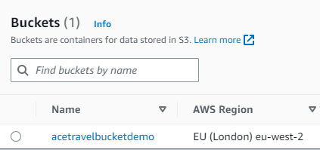
1
Select Bucket

2
Select properties.

3
Scroll down to Static web hosting and select edit

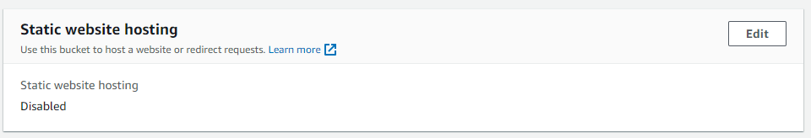

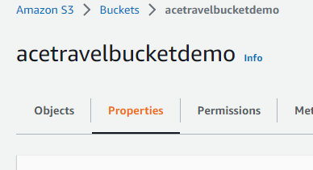
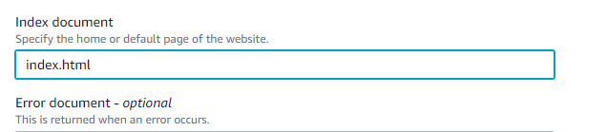
4
Specify an index page such as index.html or home.html for visitors to land on

6
Upload the html web-content file.
Note
See section 7.5 for uploading an object.
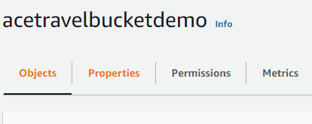

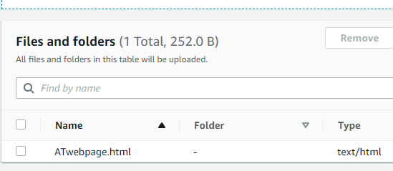
7
Return to the Bucket landing page and select permissions.

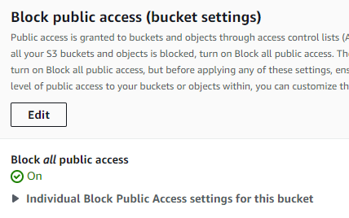
8
Select edit Block public access

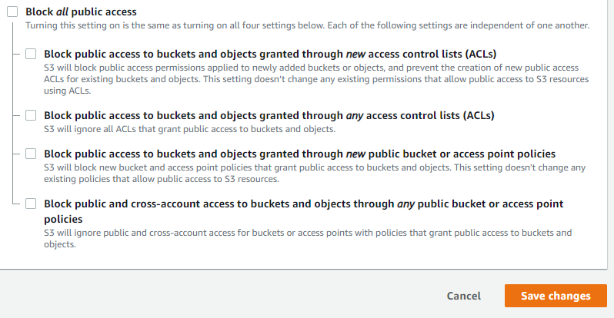
9
Ensure that all block access options are unchecked as this page will receive public traffic.
Warning!
This will result in security implications. Therefore, a bucket policy should be implemented as best practice to harden S3 bucket (Demonstrated in following steps.

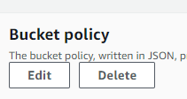
11
Create JSON policy.
Note
This policy was sources at: https://docs.aws.amazon.com/AmazonS3/latest/userguide/WebsiteAccessPermissionsReqd.html
- Action allows public to read content.
- Principle uses the “ALL” wildcard.
- Bucket name/object file path
Save changes.

10
Select edit Bucket policy.

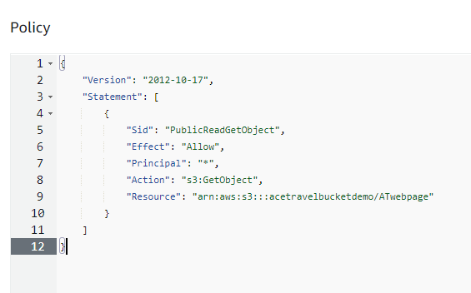

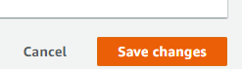

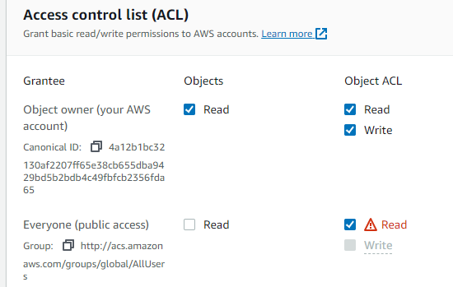
12
Edit to enable Access control lists.
Select read on Object ACL

13
Acknowledge changes and save.



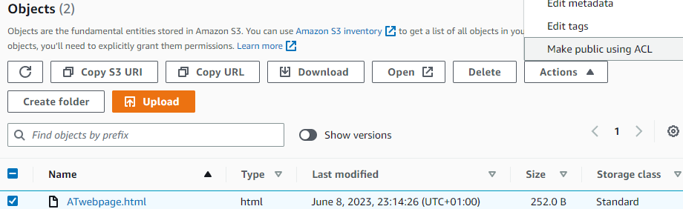

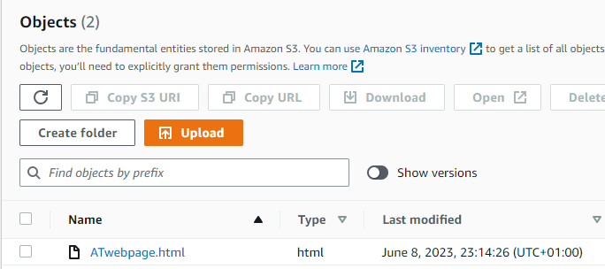
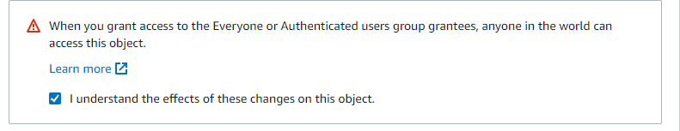
15
Navigate to the object.
14
Select Make public using ACL from the actions dialogue then acknowledge warning notification and save.

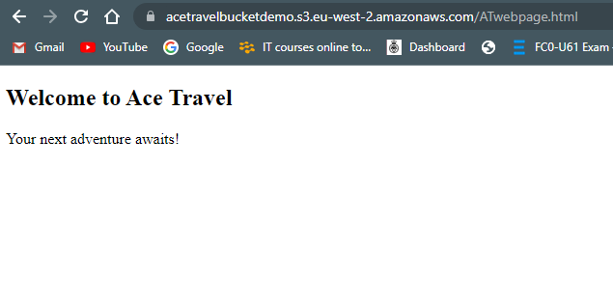
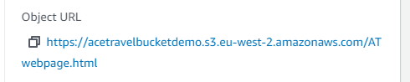
Static web page successfully created.
16
Select the link under the properties tab.

7.7 Creating EC2 Instances


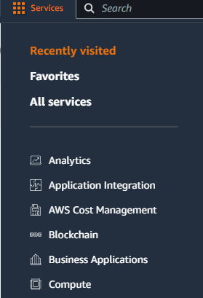
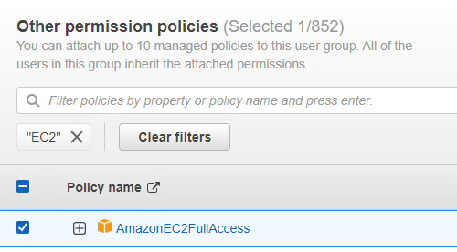
2
Privileged user signs in and navigates to compute on the console.

Selects EC2 Service

1
Ensure that user of group has the required permissions.
Note
Refer to sections 7.1 and 7.2 for full procedure.

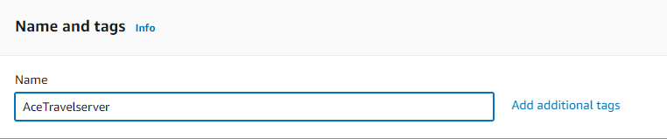
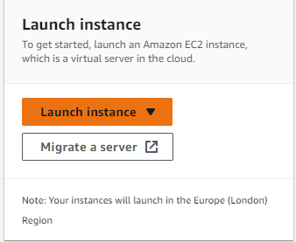
3
Select launch instance.
On the Launch Instance page begin by selecting a server

4
Select the required Amazon Machine Image (AMI)
Note
This demonstration will use the Linux Ubuntu distribution.
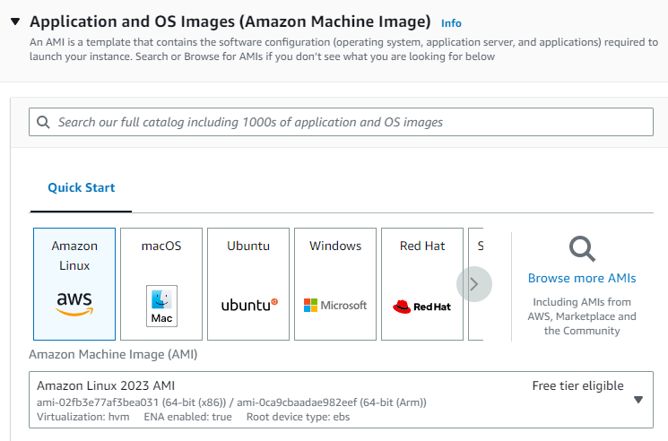

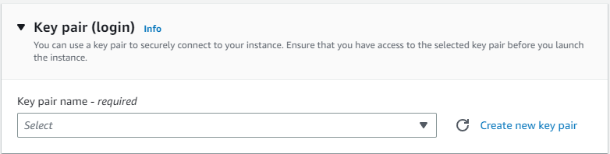

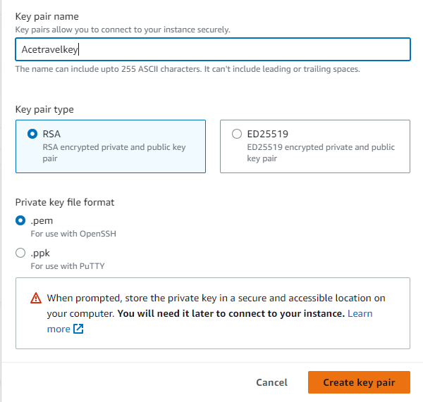
7
Choose a key pair name, the encryption type and format.
Note
RSA has been chosen for this demonstration as it is a well-established and standardised encryption algorithm.
.pem has been selected to demonstrate connecting to the instance using ssh.
Once items selected, create key pair.

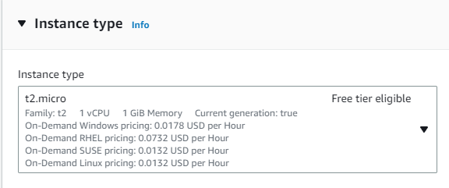
5
Select Instance type.
Note
T2 micro chosen for demonstration purposes.
6
Select create Key Pair
Note
Key pairs may be required to access a machine remotely.

9
Configure network and security groups.

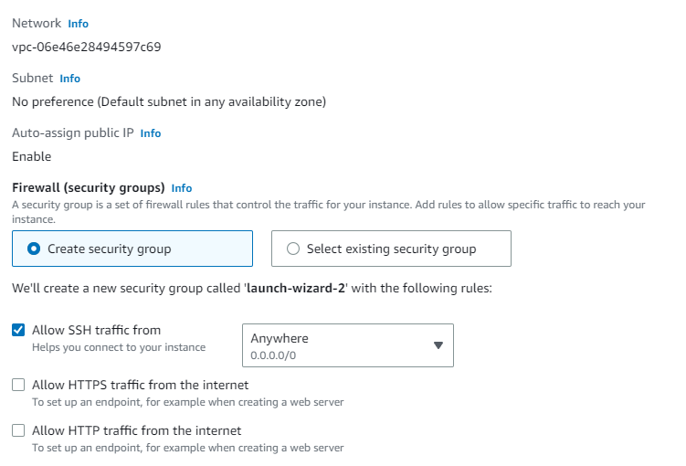

Note
Default security group rules will allow inward traffic on port 22 ssh connection, and all outward traffic.
8
Store key in secure, accessible location.
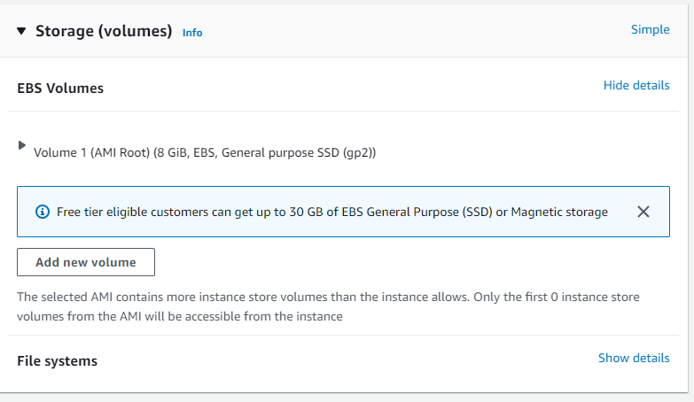

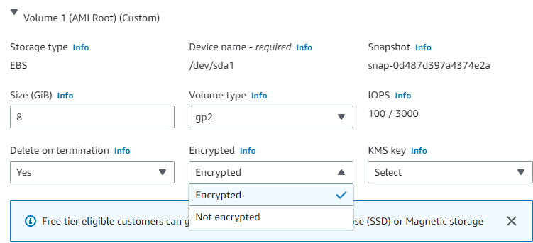
10
Configure storage.
Note
Best practice encourages opting to encrypt storage by selecting volume and selecting encrypt storage.
Check summary and select Launch Instance when complete.

7.8 Connect to EC2 with SSH Windows Power Shell
Note
Check the instance has an internet gateway on the VPC prior to connecting to SSH.

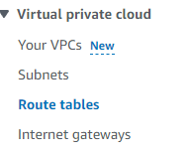
3
Select route tables in the VPC.
Select Route table ID

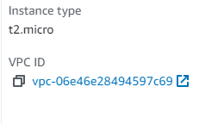
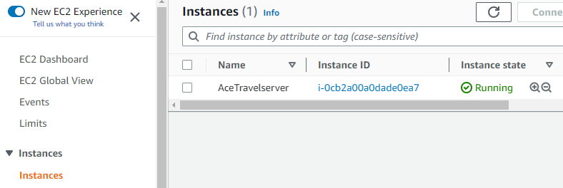
2
Select VPC ID
1
Navigate to EC2 instance and select the desired instance.

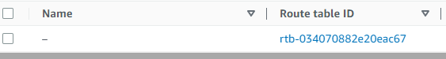

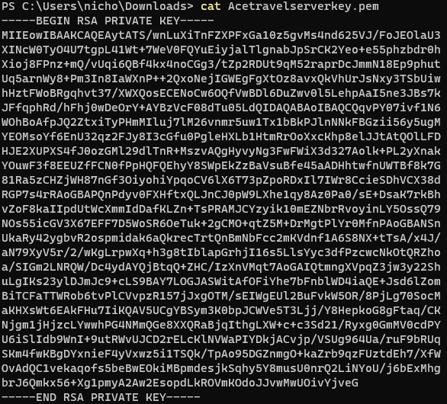
5
Open PowerShell use the command cat with the key name to confirm that the key is in the keys stored file.

4
Confirm that internet gateway is with the VPC.

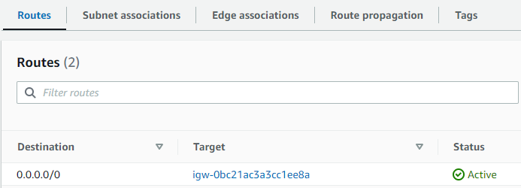

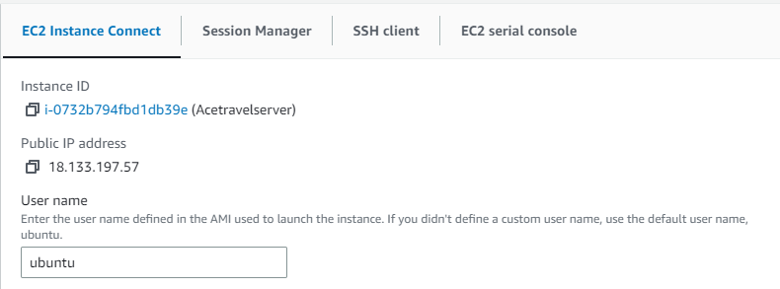
Note
To view username and public IP select connect on instance.
Select EC2 instance connect.

Key name

Public IP
Username

6
Use the ssh -i command with the key name then username/ public Ip address.

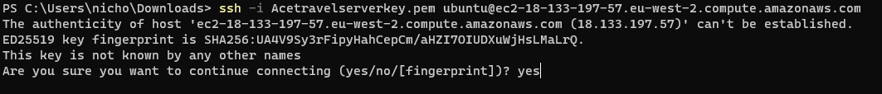

7
Input yes to verify first connection.
Successfully connected to EC2 from local system.

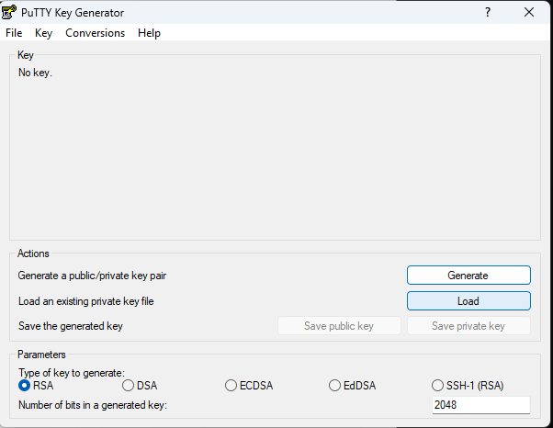
7.9 Connect to EC2 using Putty.

1
Open Putty key generator (Puttygen) and select load.

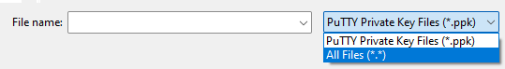
2
Select all files and search for pem file key. Press open.

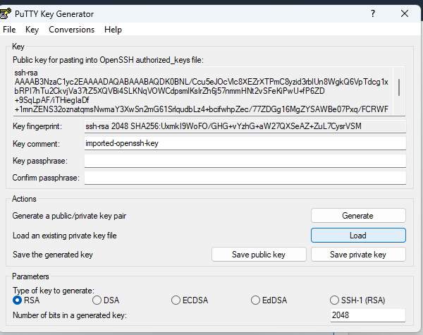

4
Open Putty application and input username and public IP of EC2 instance
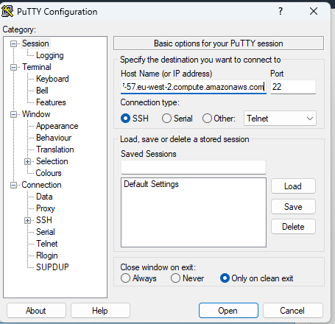
3
Select save private key.
Name key and store in accessible location

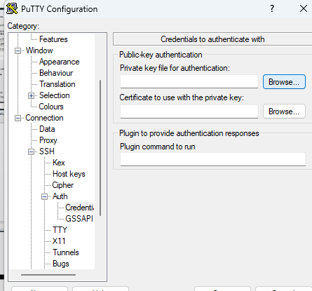

5
Expand SSH tree, then expand on Authorisation tree and browse private keys.
Select private key.

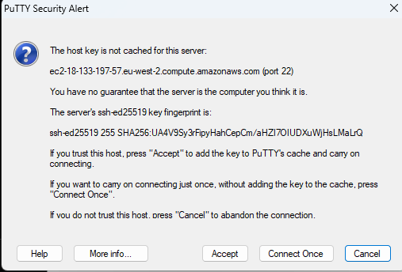

8
Press open and accept verification notification.
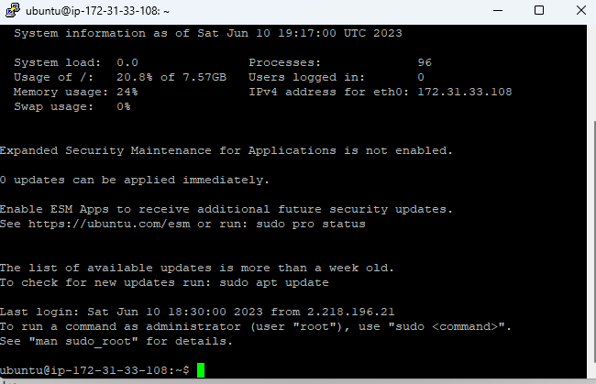
Successfully connected to EC2 from local system,

Security Controls Manual

Enabling Object Lock

Note
Enabling Object Lock preserves the integrity of object data by ensuring that the object cannot be modified by an unauthorised entity. This provides assurance and helps AT maintain compliance with regulation such as the DPA 2018 and PCI DSS.

Object Lock must be enabled at object creation (See section 7.4 for create bucket)

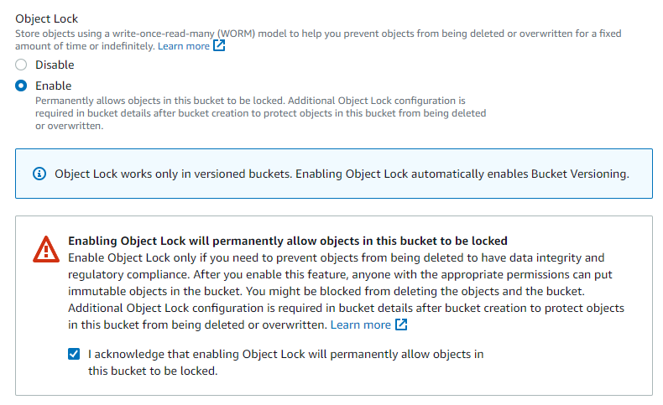

2
Select Enable and check acknowledgment box
1
At bucket creation select advanced settings

3
Upload object (as shown is section 7.5) and select object.

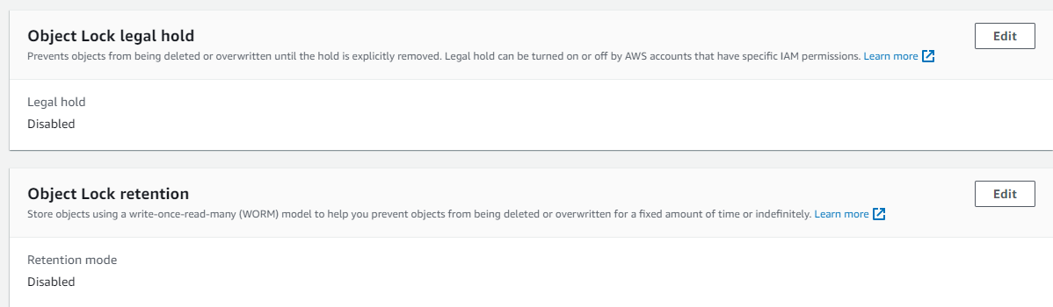
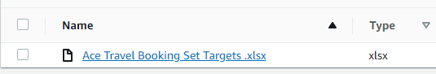
Note
Legal hold will lock the object for indefinitely. Until the lock have been removed by a user with permissions
Retention will lock object for a period. This is subcategorised into governance mode – where user with sufficient privileges can override lock, or compliance, where the object will remain locked to all users for the retention period.
This demonstration will enable a legal hold.

4
Scroll to the bottom of the page under the properties tab of the object.
Select legal hold or retention.

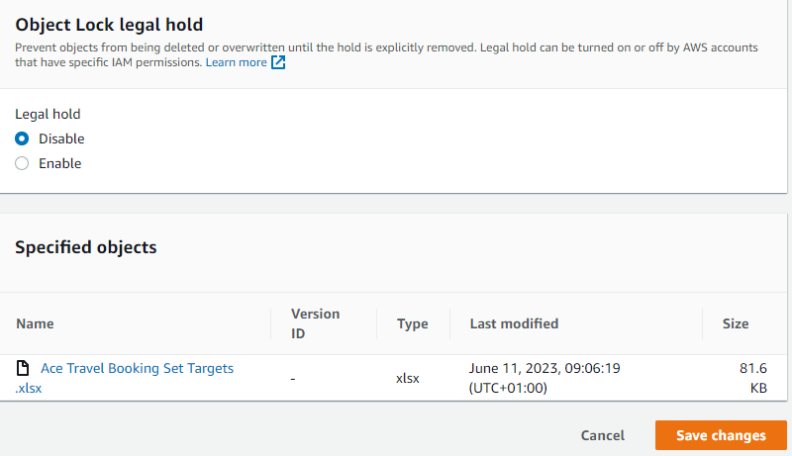
5
Enable legal hold and save changes.

Bucket Versioning
Note
Bucket versioning will aid AT allowing the recovery of previous versions of an object once it has been modified or deleted.
This demonstration will delete existing object and restore the previous version.
Bucket versioning is automatically enabled with object lock

1
Select object and delete.

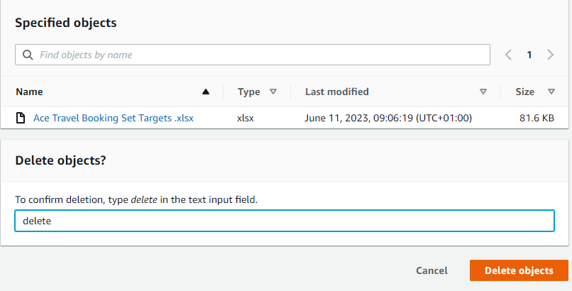
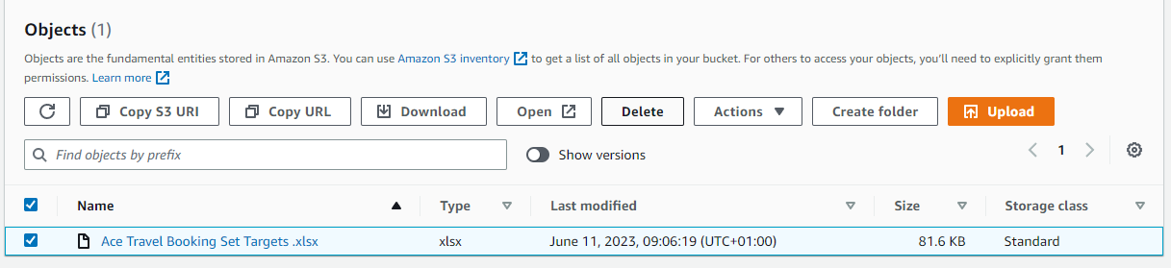
2
Input delete and select delete object.

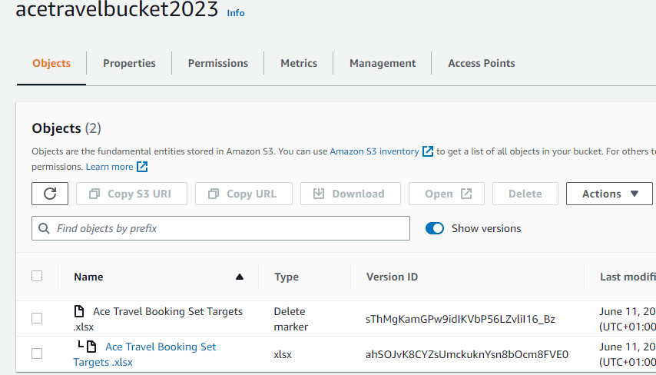
4
The previous object will be shown below a delete marker.
Delete the delete marker.

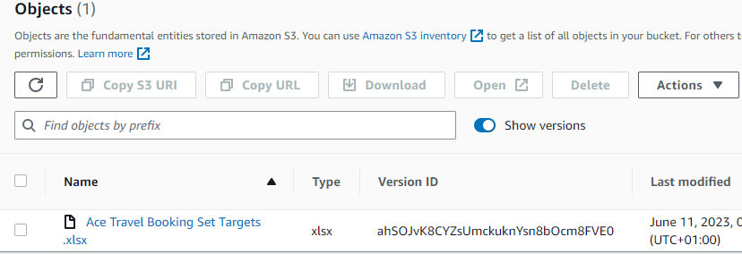

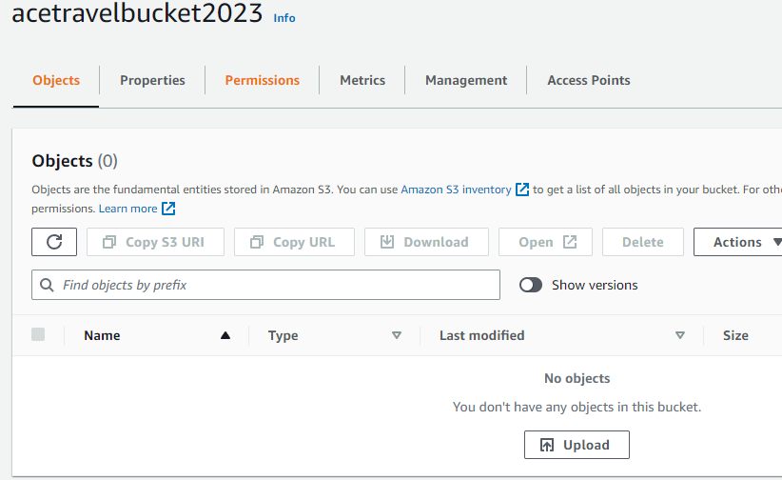

3
Under the deleted objects bucket, toggle the show versions widget.
Previously deleted object has been restored.

Enabling SSE-KMS Server-side encryption.
Note
The demonstration in section 7.4 for creating a bucket used SSE-S3 default encryption. This grants everyone with permissions access to the object.
However, enabling SSE-KMS will give AT an extra layer of security and protection for the confidentiality of its data.

1
Navigate to the Bucket and select the properties tab.

2
Scroll to Default Encryption and select Edit.

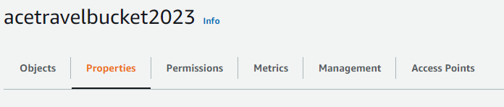

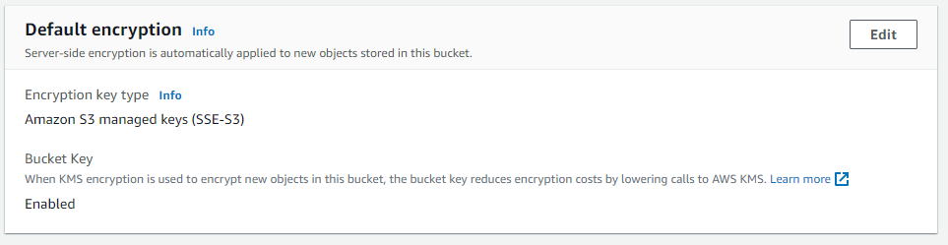

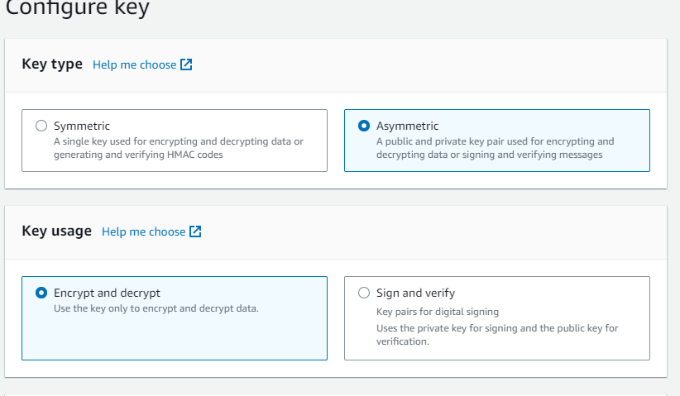

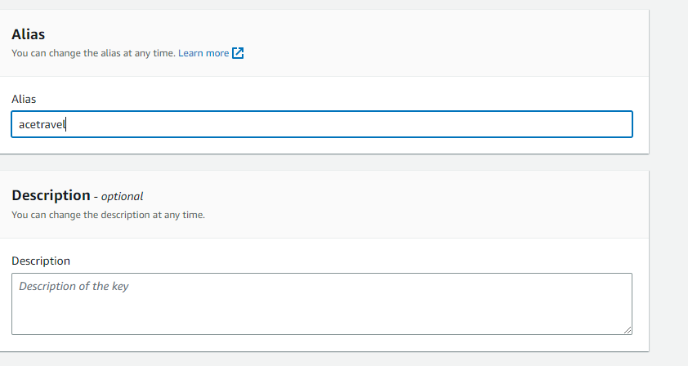

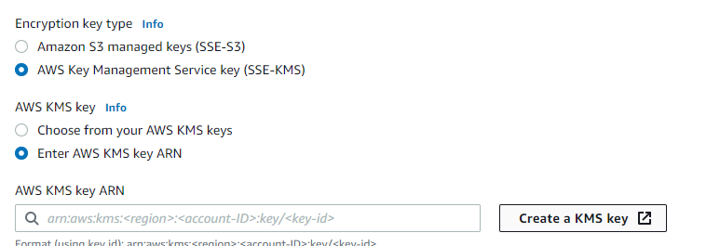
3
Select SSE-KMS and create key

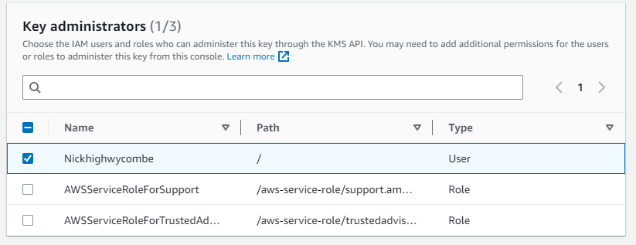

6
Define which users will have administrative permissions.
5
Choose labels.
4
Configure key to the required specifications.

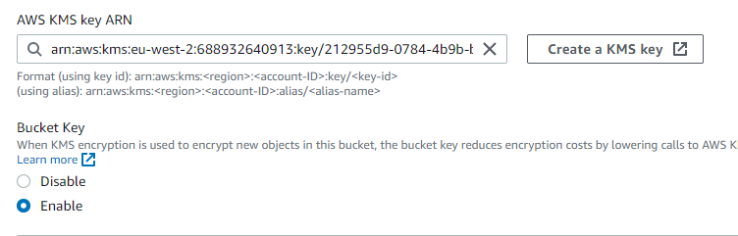

SSE-KMS encryption successfully enabled.

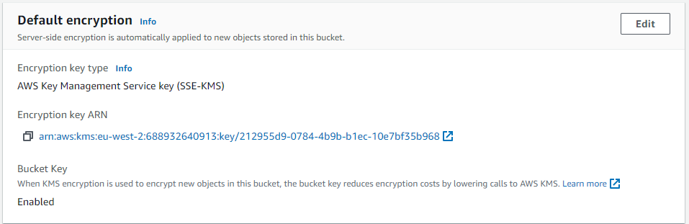

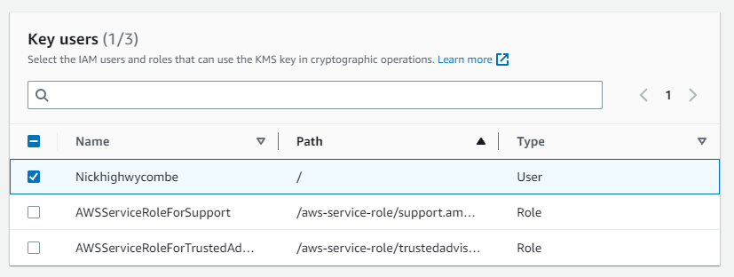
8
Return to bucket (or object) properties tab and enter ARN.
Note
ARN located at KMS service.

7
Define User permissions.
Review and accept.

8.4 IAM Access Analyser for S3
Note
IAM access analyser is an auditing tool that will detects any access control issues and report the finding. This will aid AT with maintain compliance.

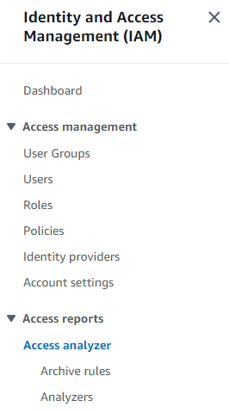

1
Navigate to the IAM service and select IAM Access Analyser from the side toolbar. Ensure that the region is selected for the analyser.

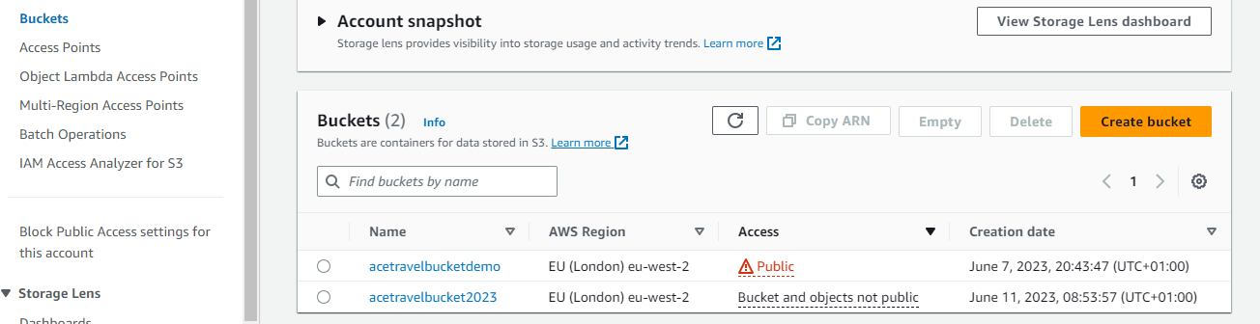
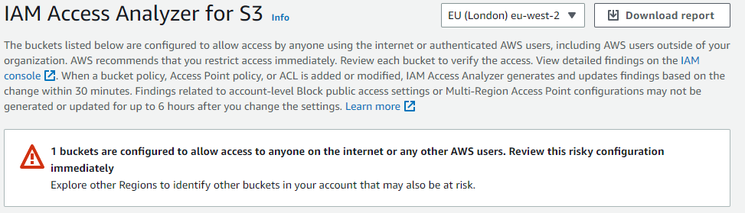
2
Navigate to S3 and select IAM access analyser for S3.
IAM access analyser will generate report.
Note
Following steps will demonstrate how to take action to mitigate configuration risks.
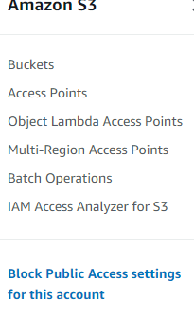
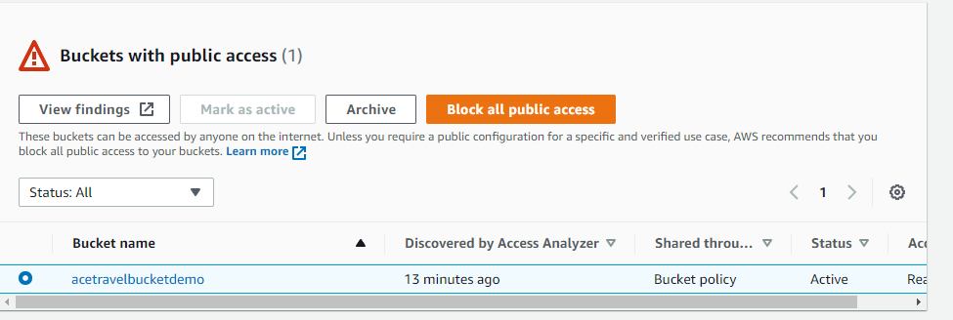
3
Select risk identified by IAM access report and select block all public access.

4
Block access at account level using the tool bar.



Encrypt a running EC2.
1
Navigate to EC2 service then select volumes in the side tool bar.
Note
Section 7.7 stated that it is best practice to encrypt elastic block storage. However, if an existing configuration is without disk encryption, follow the steps outlined in this section to replace existing root volume with encrypted copy of snapshot to protect the confidentiality of data at rest.
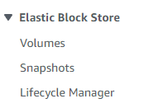

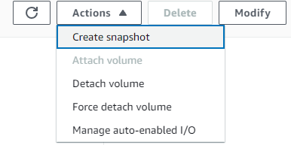
2
Under actions select create snapshot

3
Input description and tags and create snapshot.
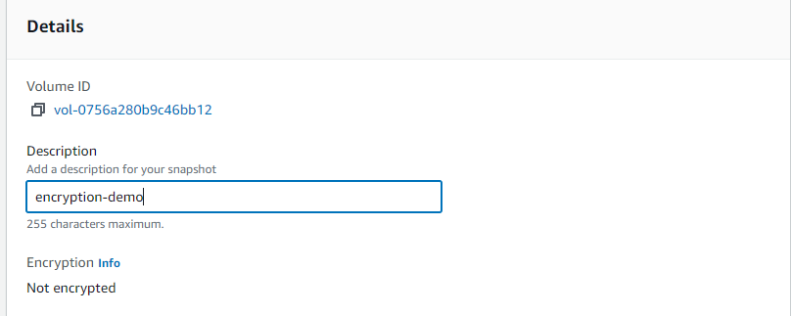

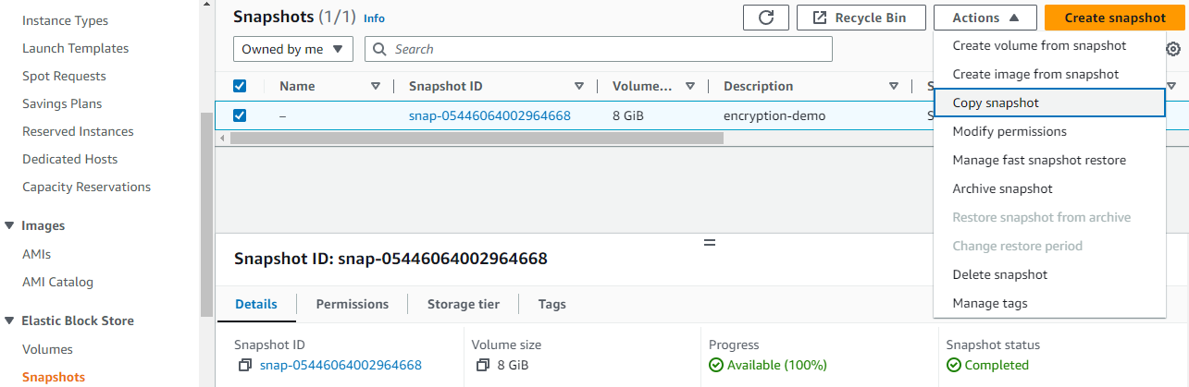
4
Select snapshots on the side bar and select copy snapshot from the actions dialogue.

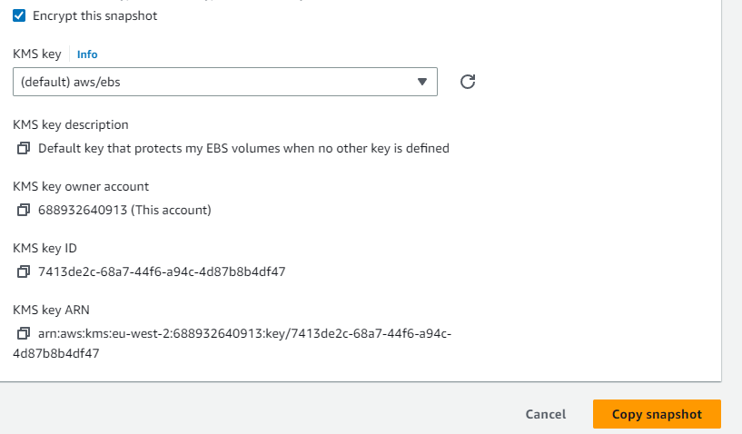
5
Check box for encrypt snapshot.
Copy snapshot.

6
Navigate to the EC2 instance and select replace root volume under storage.

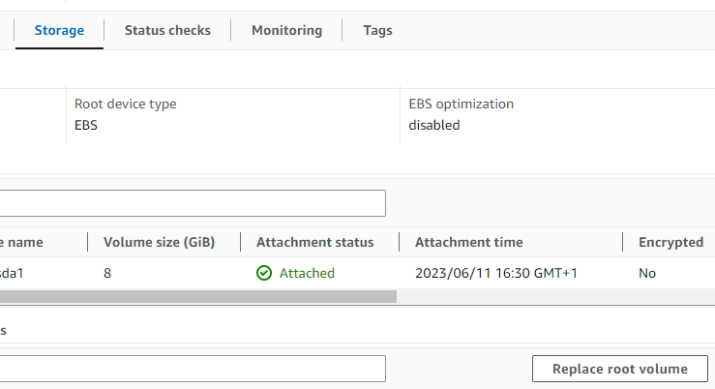

7
Select snapshot, then input the snapshot (copy) and create replacement task.

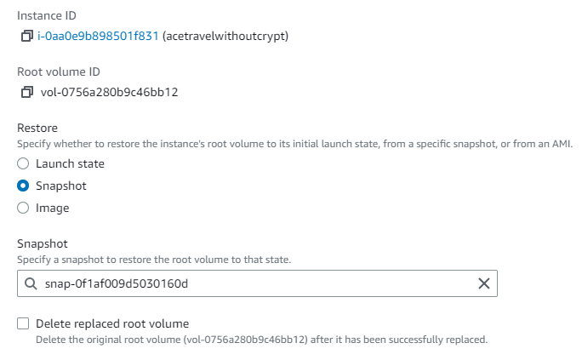


8.5 Configure EC2 Security Groups
Note
This section will deploy a security group to enhance the security of AT’s data in transit.

1
Navigate to EC2 instance obtain the instances virtual private cloud ID.

2
Navigate to the EC2 dashboard and select security groups.


3
Select create security group.

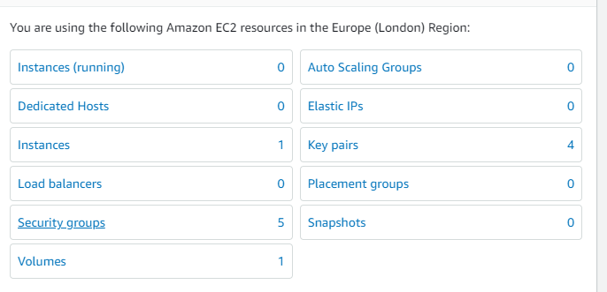

4
Input basic details. Paste copied Virtual Private Cloud ID.

5
Create in in bound rules. Create security group.
Note
This instance will only receive inbound ssh traffic from the local machine

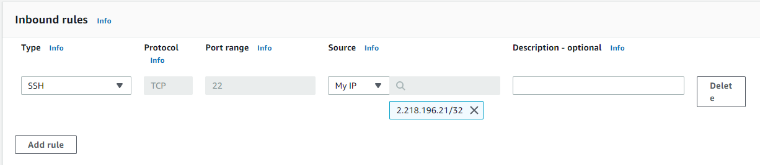
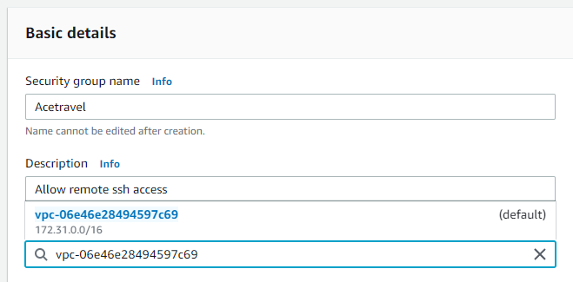
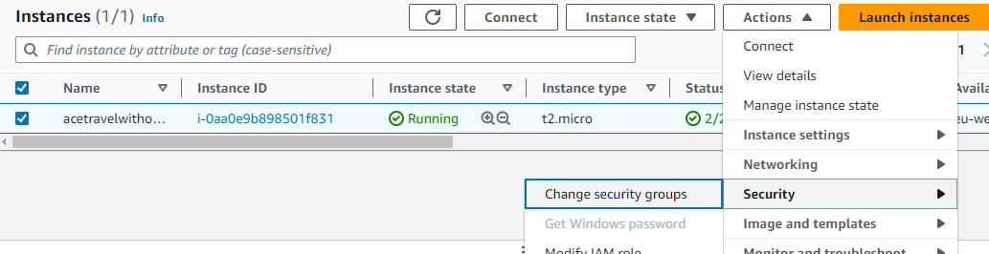
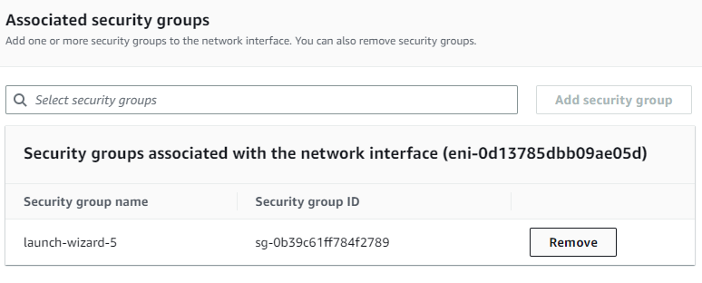
6
Navigate to instances, select instance.
Select security from the actions dialogue, then change security group.
7
Remove existing default security group.

8
Select required security group then save.

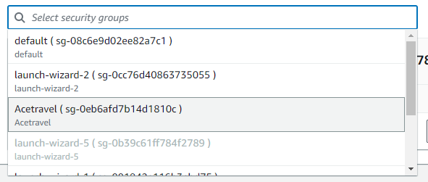

9. Data Driven Dashboard

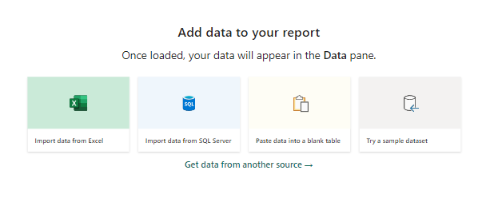
9.1Getting and transforming data

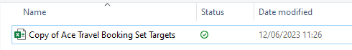
1
Select data source to input data.
Note
This example will use a locally saved excel file which relates to the company’s travel booking set targets.

2
Select the preferred table within the object and select transform data. This will bring up the power query editor – here the data can be cleaned before use.

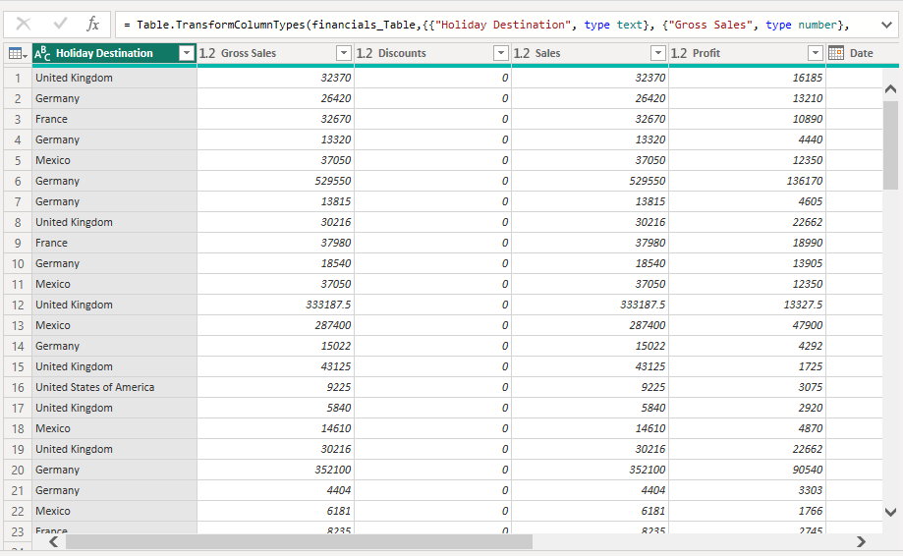

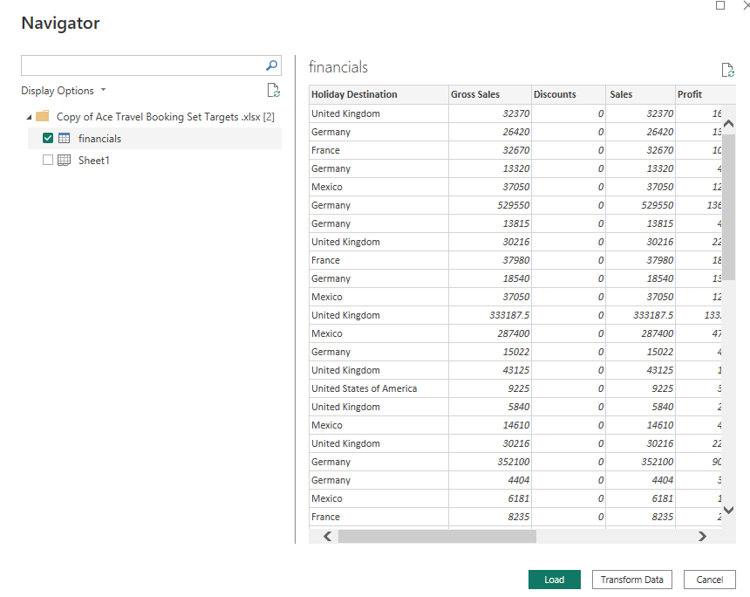
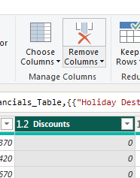
3
In this demo, there is no input data in the discount’s column, therefore the discounts column shall be removed.

4
This demonstration will change the data type of the sale to a whole number to simplify the analysis.
Right click on column, select change type, select whole numbers

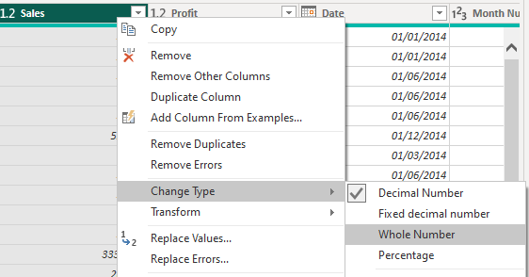

7
Select close and apply
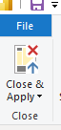
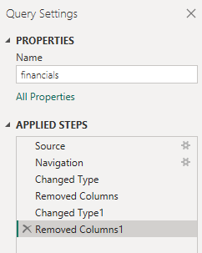
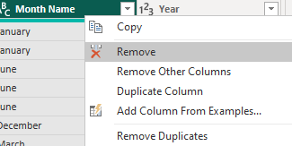
6
Review all changes on applied steps.
Note
Click on cross to the left of an applied step to reverse the change.

5
All redundant and duplicate datatypes were removed.

9.2 Building a visual report.

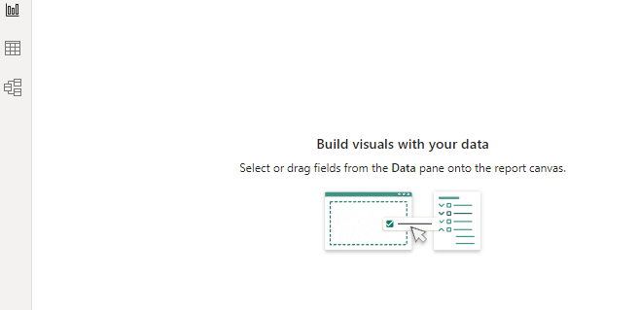

3
Select the data filters.

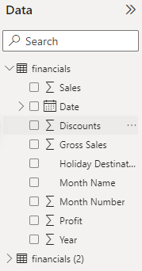
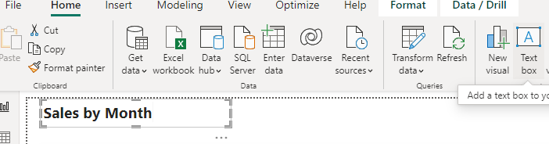
2
To create a visual display of sales by month. First insert a text box with the name of the visual display.
1
On the Power BI dashboard, select report view.

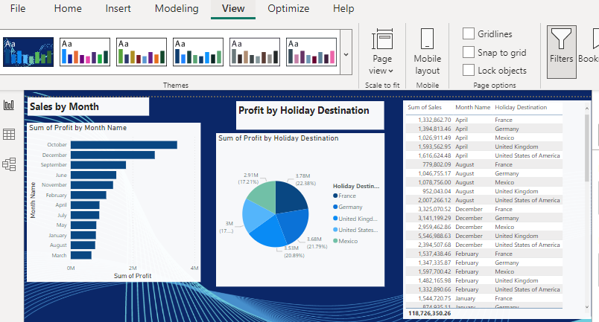
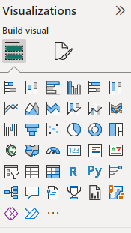
5
Customise the visual display using the view ribbon.
4
Select visual display type.

9.3 Publishing and report sharing.
1
Open file ribbon and select publish, then publish to power BI.
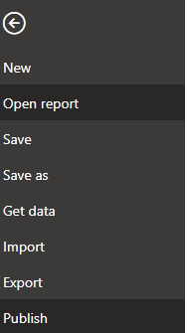

3
Select save to Power BI workspace.
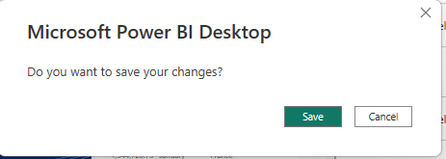
2
Select save.

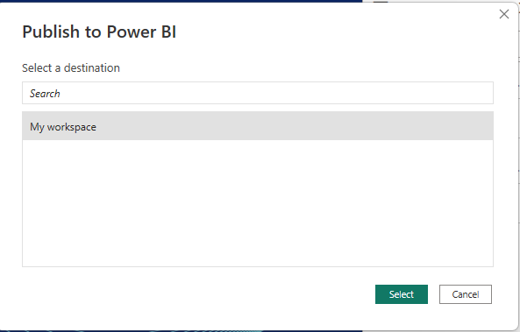
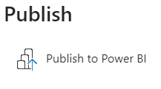

4
Report successfully saved to Power BI workspace.
Click on link to access report.

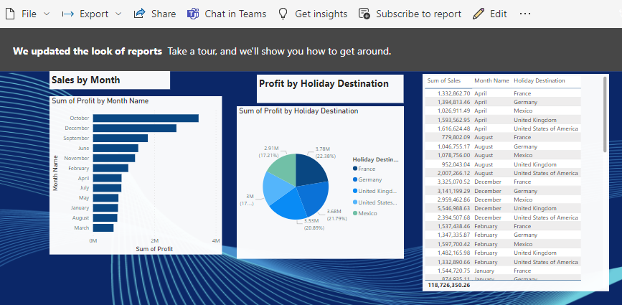
5
Interactive report is displayed. Clicking on a particular month displays the sum of sales over a month relating to a specific holiday destination.

Note
Use the share function to share report and collaborate.

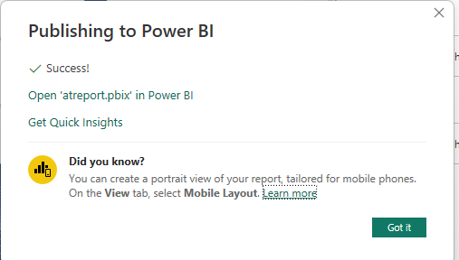

9.4 Creating a cyber security dashboard.
Note
The aim of this cyber security dashboard is to analyse trends between cyber incidents and profit loss over the previous financial year for Ace Travel.

1
Annual Financial information was pulled from a source and transformed.

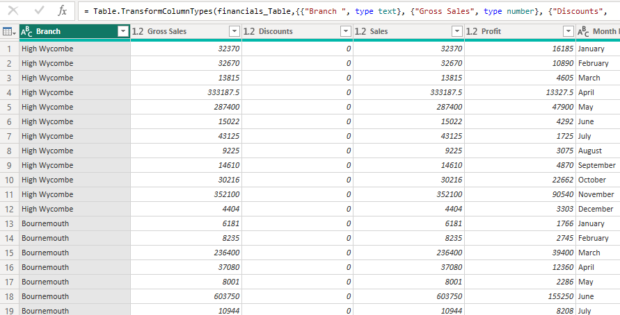
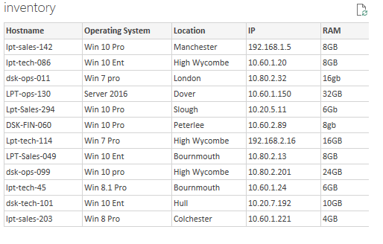
2
An inventory of servers was used to associate properties from the inventory to the financial report.
Note
Only properties such as hostname, IP address and location are relevant.

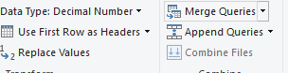
3
Select merge queries.

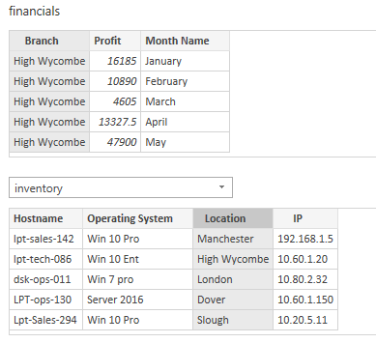

4
Merge the branch values on the financial report with the location values on the server inventory.

5
Expand the merged inventory table properties in the financial report so that columns for inventory hostname and inventory IP are added to the dataset.

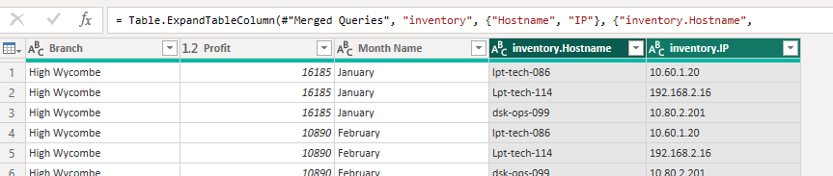

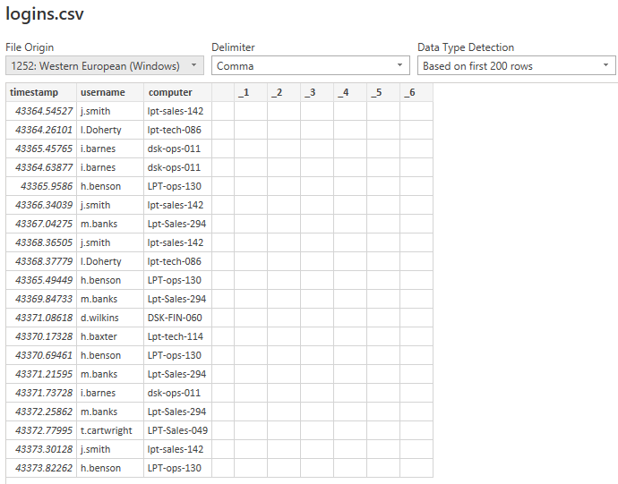
6
A CSV file of server logins was used to obtain usernames.

7
Select group by to eliminate duplicates in the login table.
Specify usernames and computer (servers)

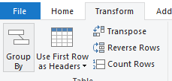

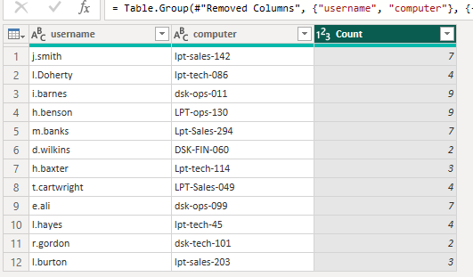
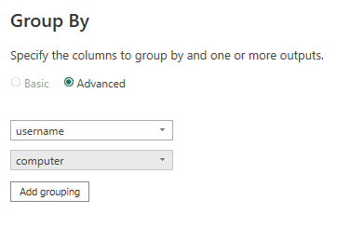

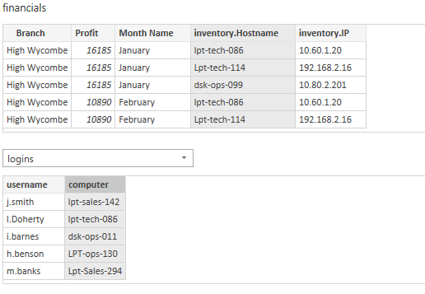
8
Merge properties of the logins table with the financials, by associating the values of inventory.Hostname and computer.
Both contain the values of the servers.

9
Expand the username properties from the login table in the financial tables.

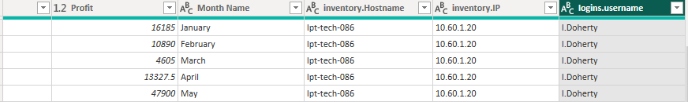

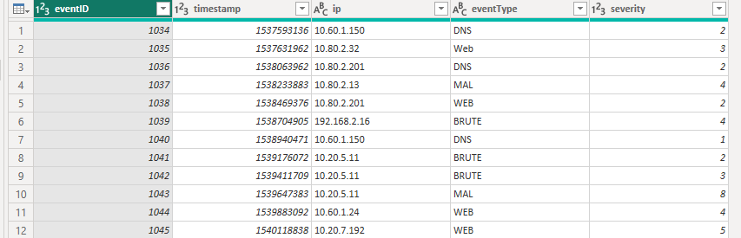
10
The security information and events management (SIEM) JSON file was pulled for ETL.

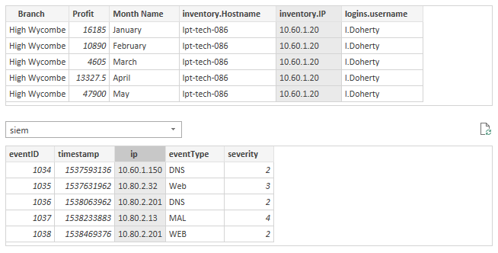
11
Merge the SIEM table properties to the financial table by associating IP address values.

12
Expand the SIEM table properties in the financial table to show the event/types (Cyber incidents), associated with each IP address, username, and branch.

C

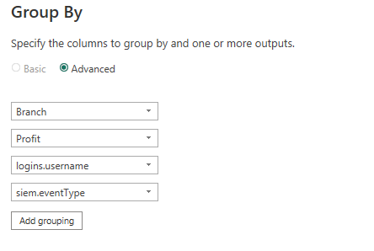
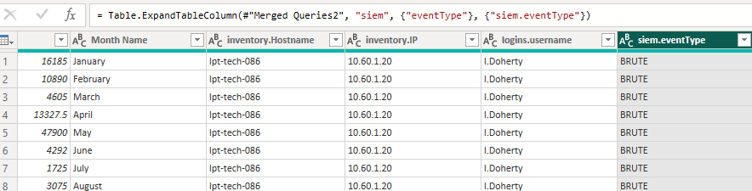
13
Group by branch, profit, usernames and events

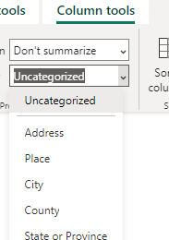
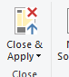
15
Select branch and change the data to a geographical type using the column tool bar.

14
Close and apply.

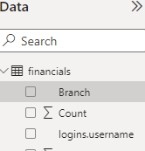

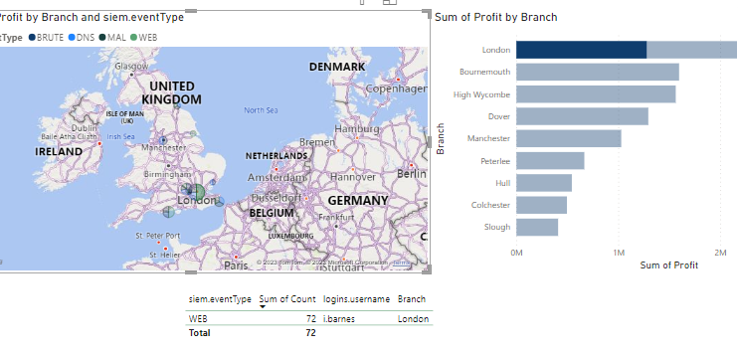
User can create and interactive dashboard where regional offices can be selected and obtain data on previous attacks, showing the office, username of the victim and the attack type. This can also be used to analyse trends in business losses resulting from downtime.

Best Practices for Social, Ethical, and Legal compliance.

Despite the numerous advantages of cloud computing and the opportunities to gain valuable insight into business decisions from big data, there are inevitable security and privacy implications. According to NIST-800-144 (Mell & Grance, 2011b, p.14), AT must consider the fact that in a public cloud deployment, their data and applications will be displaced from their organic assets to the infrastructure of a third party, potentially in proximity to malicious actors, which raises numerous concerns over security and data privacy.
However, Hayashi (2013 p. 509) critiques the broad-brush terminology applied by the NIST and numerous contemporary academics and practitioners who often couple privacy with confidentiality – a subset of security principles, arguing that data privacy encompasses a much wider scope of non-technical considerations.
This becomes relevant to AT because although there are concise methods of technical risk mitigation outlined in this document, the company must consider data privacy along social, ethical and legal dimensions which are prone to variations across regional and demographical domains.

Social consideration

Social implications should be considered along the sheer scale of big data in the cloud, and the capacity to ingest and process such a large volume, variety, and velocity of data. In the context of AT which operates in the UK, this must be mapped against what is a commonly shared perception in western society of one’s fundamental right to individual privacy (Chiew et al., 2018, p. 1).
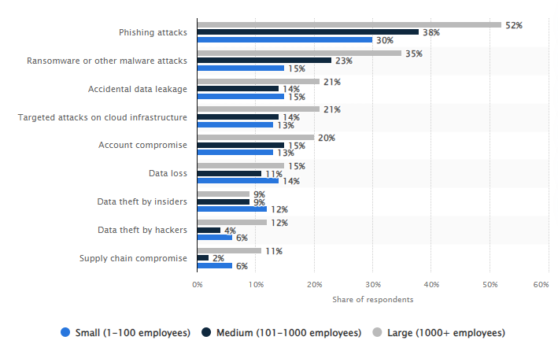
According to the Mell & Grance, (2011b, p. 15), the shared responsibility between the CSP and the service user becomes an increasingly daunting task when managing the risks relating to privacy in the cloud. As a large company, with a high turnover, AT will likely incur the same cloud security risks as most large companies worldwide. The source (figure 4) shows that 52% of respondents in the survey experienced phishing attacks. This source is supported by Javed Butt et al (2021) who cross references several sources and reports that phishing scams rose 600% in the same year as survey conducted by the source.
Figure 7: Cloud Security Incidents by Company Size 2020 (Source: Statista, 2023)
Phishing emails are an attack method whereby an attacker scams a victim by posing as a legitimate entity, this can take many forms such as spear phishing whereby an individual is targeted, whaling which focuses on high value targets such as a system administrator, or traditional email and text message mediums (Butt et al., 2022, p. 3050).
They are of particular interest in the context of the social environment because this attack requires interaction from the victim and from an organisational perspective a secure process is often compromised by a vulnerability in the human factor, when emotional defects such as fear or greed are activated by a process referred to as social engineering.
Once a victim is successfully compromised, the attacker retrieves sensitive information such as PII or authentication credentials to gain escalated privileges to a target system or network and launch a payload such as Ransomware.
Nifakos et al (2021, pp. 9-10) argues that the human factor in the form of employee carelessness the chief activator of most data breaches, against the common perception that they are attributed to external hackers. It is the opinion of Nifakos et al (2021, p.10) that companies should use standard frameworks such as the ISO to mitigate this threat.
This opinion could be substantiated by the Dropbox 2012 incident where an employee’s account was compromised by a password reuse in a LinkedIn account to gain access to the CSP’s database (Chiew et al., 2018, p. 6). However, Dropbox is certified as being compliant with the ISO/IEC 27001, which is a commonly adopted framework for an information security management system and the ISO/IEC 27017 and ISO/IEC 27018 which are cloud specific developments of the ISO/IEC 27000 series, the latter relating to data and privacy (Dropbox, 2023).
This attack was mitigated by the implementation of encryption controls which is a mechanism that CPS’s must implement to remain compliant with prominent standard frameworks such as that of the ISO/IEC 27018. This demonstrates that having adequate controls applied holistically and adopting a defence in-depth approach if effective when mitigating vulnerabilities in the social environment.

10.2 The role of ethics

The exact meaning of ethics in contrast to the social environment is much debated among philosophers. However, in the context of fields that relate to data privacy, Aşuroğlu & Gemci (2016, p. 141), defines ethics in contrast to law as a driver to adopt behaviours in alignment with socially accepted behaviours and actions, and believes that whereas law achieves the optimal outcome by control, ethics achieves this by innate moral codes that exist within individuals and groups.
This illudes to the threat that emerges from the human factor at the source, in reference to the willingness of AT employees or employees to of their CSP to make decisions or take actions that will knowingly compromise the data privacy of customers.
The Capital 1 data breach of 2019 is an example of the gravity of the CSP based insider threat. According to Neto et al (2020, pp. 6-7), 106 million Capital one customers were affected when a previous AWS employee developed a software tool that allowed her to identify servers rented from AWS by Capital 1 with misconfigured firewalls, allowing the execution of commands from outside to penetrate and to access the servers.
Neto et al (2020, p.20) concludes that Capital 1 was ultimately held responsible, and that they had failed to implement proper controls, and that compliance with cyber security frameworks such as NIST or ISO would have been sufficient to mitigate the attack.

Legal issues

OWASP lists Accountability and Data ownership at the top 10 of cloud risks (Babu et al., 2020). This raises concerns because if AT decides to outsource its sensitive data to a CSP then it will have limited control over how the data is used and how security control measures are implemented, moreover it becomes increasing complicated to determine who is to be held responsible in the event of a data breach.
This is where the ethical dimension crosses with legal issues because the bronsure a level of security appropriate to the risks arising from the processing of personal data. Moreover, section 155-159 of the DPA 2018 stipulates that the Information Commissioners Office (ICO) can fine AT up to 4% of its annual revenue for a data breach.

Recommendations

AT must carefully examine the SLA which explicitly states the measurable aspects of the intended service provision such as the uptime and the security provisions for data privacy and how the company will be compensated if intended outcomes are not met.
To comply with social, ethical, and legal obligations, in is imperative that the service they use, can protect the sensitive data of its stakeholders. This means both the CSP and AT need to have mechanisms in place to manage risk effectively and implement suitable controls.
At a minimum, as shown in this section’s previously mentioned case studies AT needs to implement strong encryption algorithms, intrusion detection and prevention systems and multifactor authentication techniques on its cloud-based system.
However, to summarise the key differences in outcome of the case studies, compliance with standards proves to be a common denominator in holistic risk mitigation, especially when companies adopt known risk management frameworks for cloud, such as the ISO/IEC 27000 series with extended cloud versions, the Cloud Security Alliance and the NIST. The former two can be certified against, which aides’ companies like AT in exercising due diligence when choosing a CSP, and the ICO guidance strongly recommends assessing CSP’s through the Kitemark scheme (ICO, 2020), thus, providing certification that a service has been assessed and certified against British standards.

Conclusion

The aim of this document was to provide the necessary direction and guidance for Ace Travels cloud migration strategy so that it could exploit big data, whilst maintaining the security of its information assets.
Part A began by exploring the principles of big data and its relevant enabling technological solution – cloud computing. The former component of this hybrid concept was analysed using the commonly accepted four Vs of big data, in reference to large volumes of data, from a wide variety of sources spanning end points at a velocity which far exceeded the capacity of enterprise computational capabilities.
This was until the latter component became a paradigm, providing companies like AT with clear advantages over traditional IT infrastructure configurations, by providing ubiquitous, on-demand, pooled, computational resources, capable of exploiting big data in real time.
However, this cloud migration strategy did not come without anticipated risk. The risk assessment highlighted numerous vulnerabilities inherent in cloud architecture, some of which paralleled traditional infrastructure configurations, others that were exacerbated by the nature of cloud, thus providing a source of empowerment to threat actors.
When considering viable risk treatment plans, it was agreed that there would be several base line controls necessary to mitigate the risks, which were outlined in Part B of this document. However, the recent management report conducted its own independent management investigation, and this identified a low level of IT competency as well as ineffective security layers. Therefore, it was determined that AT should opt for a PAAS model that transfers as much risk as possible to a reputable CSP, whilst at the same time maintaining the required flexibility and agility to develop its applications to meet its big data strategy.
The latter sections of part A discussed and visualised the prominent big data framework -Hadoop, drawing contrast to the management of data storage architecture, software assurance and auditing methodologies through implementation of Hadoop framework as a standalone implementation against the adoption of a managed cloud service in the medium of EMR.
This comparative analysis identified EMR as the preferable justifiable framework since AWS, as an organisation that maintains compliance with most notable standards and regulators offers security features included within its services that will aide AT in mitigating the re-occurring risks identified in both the management report and this documents risk assessment.
The technical aspects of the cloud migration strategy were addressed in part B. The aide memoir outlined a clear step by step guide for IT technicians to configure and maintain AWS core services and showed how users could implement many of the aspects discussed in part A such as fine-grained access control, deployment of resources as well as access theses resources remotely.
This was supplemented by the security controls manual to ensure that users would be able to implement the minimum standard of acceptable security configurations and further guidance was given to create a data driven dashboard which could be used as both a tool for business intelligence and security and auditing mechanisms. However, it was noted in the following discussion that that AT should approach data privacy with distinction from the commonly misconstrued perception of ‘confidentiality of assets.
As a result of the given case studies, it was stated that AT must exercise due diligence and factor in its social, ethical, and legal obligations when entering an SLA. Therefore, thinking about the next step forward, it is advisable that AT ensures that its own best practices, and the best practices of its chosen CSP are certified against standard frameworks such as the ISO series and the CSA to provide assurance that they can meet the privacy requirements of their stakeholders throughout and beyond their cloud migration.

Table of References

AWS (2023) API Logs - Secure Standardized Logging Service - AWS CloudTrail. Retrieved 2 June 2023 from https://aws.amazon.com/cloudtrail/.
Aşuroğlu, T., & Gemci, C. (2016). Role of Ethics in Information Security the Effects of Signal Level of the Microwave Generator on the Brillouin Gain Spectrum in BOTDA and BOTDR View project Activity Recognition View project Role of Ethics in Information Security. https://www.researchgate.net/publication/307863852
AWS (2023) Automate Cloud Audits – AWS Audit Manager Retrieved 2 June 2023, from https://aws.amazon.com/audit-manager/.
Azeroual, O., & Fabre, R. (2021). Processing big data with Apache Hadoop in the current challenging era of COVID-19. Big Data and Cognitive Computing, 5(1). https://doi.org/10.3390/bdcc5010012
Babu, S., Bansal, V., & Telang, P. (2020). Top 10 Cloud Risks That Will Keep You Awake at https://owasp.org/www-pdf-archive/Cloud-Top10-Security-Risks.pdf.
Berisha, B., Mëziu, E., & Shabani, I. (2022a). Big data analytics in Cloud computing: an overview. Journal of Cloud Computing, 11(1). https://doi.org/10.1186/s13677-022-00301-w
Berisha, B., Mëziu, E., & Shabani, I. (2022b). Big data analytics in Cloud computing: an overview. Journal of Cloud Computing, 11(1). https://doi.org/10.1186/s13677-022-00301-w
Big Data Platform – Amazon EMR – AWS. (2023). Retrieved 29 May 2023, from https://aws.amazon.com/emr/.
Butt, U. A., Amin, R., Aldabbas, H., Mohan, S., Alouffi, B., & Ahmadian, A. (2022). Cloud-based email phishing attack using machine and deep learning algorithm. Complex and Intelligent Systems, 1-28. https://doi.org/10.1007/s40747-022-00760-3
Chebbi, I., Boulila, W., Mellouli, N., Lamolle, M., & Farah, I. R. (2018, March). A comparison of big remote sensing data processing with Hadoop MapReduce and Spark. In 2018 4th international conference on advanced technologies for signal and image processing 1-4. https://scholar.google.com/scholar?hl=en&as_sdt=0%2C5&q=a+conparis+of+big+remote+sensing+data+processing+with+hadoop&btnG=.
Chiew, K. L., Yong, K. S. C., & Tan, C. L. (2018). A survey of phishing attacks: Their types, vectors, and technical approaches. In Expert Systems with Applications, 106, 1–20. https://doi.org/10.1016/j.eswa.2018.03.050
Cox, M., & Ellsworth, D. (n.d.). Managing big data for scientific visualization Out-of-Core Visualization View project Michael Cox NVIDIA Managing Big Data for Scientific Visualization. https://www.researchgate.net/publication/238704525
Choudhary, A. (2021). A walkthrough of Amazon Elastic Compute Cloud (Amazon EC2): A Review. International Journal for Research in Applied Science and Engineering Technology, 9(11), 93–97. https://doi.org/10.22214/ijraset.2021.38764
ICO. (2020) Cloud Computing. https://ico.org.uk/for-the-public/online/cloud-computing/
Statista. (2023) Cloud security incidents by company size 2020. Retrieved 13 June 2023, from https://www.statista.com/statistics/1226119/cloud-security-incidents-worldwide-by-company-size/.
De Mauro, A., Greco, M., & Grimaldi, M. (2015). What is big data? A consensual definition and a review of key research topics. AIP Conference Proceedings, 1644, 97–104. https://doi.org/10.1063/1.4907823
Dropbox. (2023). Dropbox Standards and Regulations Compliance. Retrieved 14 June 2023, from https://www.dropbox.com/en_GB/business/trust/compliance/certifications-compliance.
Giyane, M., & Buckley, S. (2016). Higher education cloud computing in Zimbabwe: towards understanding trends of adoption. 77-83. https://scholar.google.com/scholar?hl=en&as_sdt=0%2C5&q=Giyane%2C+M.%2C+%26+Buckley%2C+S.+%282016%29.+Higher+Education+Cloud+Computing+in+Zimbabwe%3A+Towards+Understanding+Trends+of+Adoption.&btnG=.
Guida, S. (2021). British Airways will face record-breaking GDPR fine for suffering financial data theft of hundreds of thousands of customers. European Journal of Privacy Law & Technologies. https://ico.org.uk/about-the-ico/news-and-events/news-and-blogs/2019/07/ico-announces.
Hashem, I. A. T., Yaqoob, I., Anuar, N. B., Mokhtar, S., Gani, A., & Khan, S. U. (2015). The rise of “big data” on cloud computing: Review and open research issues. Information systems, 47, 98-115. https://doi.org/10.1016/j.is.2014.07.006.
Hayashi, K. (2013). Social issues of big data and cloud: Privacy, confidentiality, and public utility. Proceedings - 2013 International Conference on Availability, Reliability and Security, ARES 2013, 506–511. https://doi.org/10.1109/ARES.2013.66
Butt, U. J., Richardson, W., Nouman, A., Agbo, H. M., Eghan, C., & Hashmi, F. (2021). Cloud and Its Security Impacts on Managing a Workforce Remotely: A Reflection to Cover Remote Working Challenges. In Cybersecurity, Privacy and Freedom Protection in the Connected World: Proceedings of the 13th International Conference on Global Security, Safety and Sustainability, London, January 2021. 285-311. Cham: Springer International Publishing.
Karadsheh, L. (2012). Applying security policies and service level agreement to IaaS service model to enhance security and transition. Computers and Security, 31(3), 315–326. https://doi.org/10.1016/j.cose.2012.01.003
Key Strategies for Securing the Hybrid Cloud - Security News. (2023). Retrieved 14 May 2023, from https://www.trendmicro.com/vinfo/us/security/news/virtualization-and-cloud/key-strategies-for-securing-the-hybrid-cloud.
Li, J., Xu, L., Tang, L., Wang, S., & Li, L. (2018). Big data in tourism research: A literature review. Tourism Management, 68, 301–323. https://doi.org/10.1016/j.tourman.2018.03.009
Mayer-Schönberger, V., & Cukier, K. N. (2017). Big data: the essential guide to work, life and learning in the age of insight (Second Edition). John Murray.
Mell, P., & Grance, T. (2011). Draft NIST working definition of cloud computing. Referenced June. 3rd, 15(32), 2. https://doi.org/10.6028/NIST.SP.800-145
Mell, P. M., & Grance, T. Mell, P., & Grance, T. (2011). Draft NIST working definition of cloud computing. Referenced June. 3rd, 15(32), 2. https://doi.org/10.6028/NIST.SP.800-145
Mishra, S., Kumar, M., Singh, N., & Dwivedi, S. (2022). A Survey on AWS Cloud Computing Security Challenges & Solutions. Proceedings - 2022 6th International Conference on Intelligent Computing and Control Systems, ICICCS 2022, 614–617. https://doi.org/10.1109/ICICCS53718.2022.9788254
Novaes Neto, N., Madnick, S., de Paula, M. G., & Malara Borges, N. (2020). A case study of the capital one data breach. Stuart E. and Moraes G. de Paula, Anchises and Malara Borges, Natasha, A Case Study of the Capital One Data Breach (January 1, 2020). https://papers.ssrn.com/sol3/papers.cfm?abstract_id=3542567
Nifakos, S., Chandramouli, K., Nikolaou, C. K., Papachristou, P., Koch, S., Panaousis, E., & Bonacina, S. (2021). Influence of human factors on cyber security within healthcare organisations: A systematic review. Sensors, 21(15), 5119. https://doi.org/10.3390/s21155119
OWASP. (2023). OWASP API Security Project - OWASP Foundation. 2023. Retrieved 21 May 2023, from https://owasp.org/www-project-api-security/
OWASP. (2021). OWASP Top Ten - OWASP Foundation. Retrieved 27 May 2023, from https://owasp.org/www-project-top-ten/.
Perwej, Y. (2019). The Hadoop security in big data: a technological viewpoint and analysis. International Journal of Scientific Research in Computer Science and Engineering (IJSRCSE), 7(3), 1-14. https://doi.org/10.26438/ijsrcse/v7i3.114.
NCSC. (2023). Principle 13: Audit information and alerting for customers. Retrieved 1 June 2023, from https://www.ncsc.gov.uk/collection/cloud/the-cloud-security-principles/principle-13-audit-information-and-alerting-for-customers.
Ruperelia, N. (2016). Cloud Computing (Illustrated). MIT Press.
Quinn, N (2023). Big Data and Cloud Security, Big Data and Cloud security module, Master of Science in Cyber Security Technologies. Unpublished.
Rajeh, W. (2022). Hadoop Distributed File System Security Challenges and Examination of Unauthorized Access Issue. Journal of Information Security, 13(02), 23–42. https://doi.org/10.4236/jis.2022.132002
Sagiroglu, S., & Sinanc, D. (2013). Big data: A review. Proceedings of the 2013 International Conference on Collaboration Technologies and Systems, CTS 2013, 42–47. https://doi.org/10.1109/CTS.2013.6567202
Syed, A., Gillela, K., & Venugopal, C. (2013). The future revolution on big data. Future, 2(6), 2446-2451. www.ijarcce.com
Yang, P., Xiong, N., & Ren, J. (2020). Data security and privacy protection for cloud storage: A survey. IEEE Access, 8, 131723-131740. https://doi.org/10.1109/ACCESS.2020.3009876

